

**CIPS Message Definition Report**

**Part 1: Clearing and Settlement—Payment**

**V1.0.0**

**January 2021**

Important Note: This Article is made out in both English and Chinese versions. We hereby set Chinese version as standard and English version as a reference should any conflicts occurred. If you have any questions, please contact us at bzb@cips.com.cn.

**Revision Record**

|  |  |  |  |
| --- | --- | --- | --- |
| **Version Number** | **Date** | **Revision Note** | **Scope** |
| V1.0.0 | 26-10-2019 | [C]  CIPS Message Definition Report Part 1: Payment | All |

Note: Change statuses are C — created, A — added, M — modified, and D — deleted.

**Table of Contents**

**1 Introduction 1**

1.1 Terms and Definitions 1

1.2 Abbreviations and Acronyms 1

1.3 Document Scope and Objectives 1

1.4 References 2

**2 Scope and Functionality 2**

2.1 Background 2

2.2 Scope 2

2.3 Groups of MessageDefinitions and Functionality 3

**3 BusinessRoles and Participants 3**

3.1 Remittance Business 3

**4 BusinessProcess Description 4**

4.1 Customer Credit Transfer 5

4.2 Financial Institution Transfer 5

4.3 Batch Customer Payment 6

**5 Description of BusinessActivities 8**

5.1 Customer Credit Transfer/Financial Institution Transfer 8

5.1.1 Normal Scenario of Customer Credit Transfer 8

5.1.2 Special Scenario of Customer Credit Transfer 9

5.2 Batch Customer Payment 10

**6 BusinessProcesses 11**

6.1 Customer Credit Transfer 11

6.1.1 Normal Process of Customer Credit Transfer 11

6.1.2 Special Process of Customer Credit Transfer 12

6.2 Financial Institution Transfer 14

6.2.1 Normal Process of Financial Institution Transfer 14

6.2.2 Special Process of Financial Institution Transfer 15

6.3 Batch Customer Payment 17

6.3.1 Normal Process of Batch Customer Payment 17

6.3.2 Special Process of Batch Customer Payment 17

**7 Example 18**

7.1 CustomerCreditTransfer <cips.111.001.02> 18

1. Introduction
   1. Terms and Definitions

The terms involved in this document are defined as follows:

|  |  |
| --- | --- |
| **Term** | **Definition** |
| BusinessRole | A BusinessRole represents an entity (or a class of entities) of an actual business. |
| Participant | A functional role played by a BusinessRole in a particular BusinessProcess or BusinessTransaction. |
| BusinessProcess | Business activities undefined but undertaken within a BusinessArea whereby each BusinessProcess fulfills one type of business activities and whereby a BusinessProcess may include and extend other BusinessProcesses. |
| BusinessTransaction | A particular solution that meets the communication requirements and the interaction requirements of a particular BusinessProcess and BusinessArea. |
| MessageDefinition | Formal description of the structure of a message instance. |

The CIPS terms involved in this document are defined as follows:

|  |  |
| --- | --- |
| **Term** | **Description** |
| Cross-border Interbank Payment System (CIPS) | CIPS provides fund clearing and settlement service for its Participants’ cross-border RMB payment transactions, financial market transactions, etc. |
| CIPS Direct Participant | CIPS Direct Participant refers to a domestic or an overseas institution that has a CIPS code and handles cross-border RMB payment and settlement businesses directly through CIPS. The operating agency of CIPS will open a CIPS account for each Direct Participant bank, and will also open a CIPS account for each Direct Participant FMI as required by prudent management. |
| CIPS Indirect Participant | CIPS Indirect Participant refers to a domestic or an overseas institution that has not opened a CIPS account but has a CIPS’ bank code and entrusts an appropriate CIPS Direct Participant to handle cross-border RMB payment and settlement businesses through CIPS. |
| Initiator | Initiator refers to an individual or institution that initially creates a payment or information request. |
| Receiver | Receiver refers to an individual or institution that ultimately receives a payment or information request. |
| Customer Credit Transfer | Customer Credit Transfer usually refers to a remittance in which at least one party of the debtor and the creditor is a non-financial institution. |
| Financial Institution Transfer | Financial Institution Transfer usually refers to a remittance in which both the debtor and the creditor are financial institutions. |
| Batch Customer Payment | Direct Participants can send payment orders to CIPS in the form of batch packing so as to handle the customer credit transfer business of their own, indirect participants with business relations established and their agents. Batch Customer Payment adopts deferred netting settlement (DNS). |

* 1. Abbreviations and Acronyms

|  |  |
| --- | --- |
| Abbreviation/Acronyms | Definition |
| CIPS | Cross-border Interbank Payment System |

* 1. Document Scope and Objectives

This document is the first part of the Remittance Message Definition Report (MDR) and describes the BusinessTransactions and underlying message set. For the sake of completeness, the document may also describe the BusinessActivities that are not in the scope of the BusinessProcesses covered in this document.

This document describes the following:

- the BusinessProcesses scope

- the BusinessRoles involved in these BusinessProcesses

The main objectives of this document are as follows:

- to explain the BusinessProcesses and BusinessActivities these messages have addressed

- to explain the BusinessProcesses and BusinessActivities these messages have addressed

- to give a high-level description of the BusinessProcesses and associated BusinessRoles

- to explain the BusinessProcesses and related Participants

- to present a list of MessageDefinitions

* 1. References

| **Document** | **Version** | **Date** | **Author** |
| --- | --- | --- | --- |
| Message Exchange Standard for CNAPS2 | V1.4.7 | 05-2017 | China National Clearing Center, the People’s Bank of China |
| CIPS (Phase II) Requirements Specification | V1.0.0 | 05-2017 | China National Clearing Center, the People’s Bank of China |
| CIPS Message Exchange Standard V2.1.0 | V2.1.0 | 11-01-2019 | Payment System Development Center, China National Clearing Center, the People’s Bank of China |
| Requirements Specification for Multi-debit/credit Transfer by Clearing Institution | V0.5.0 | 01-2019 | China National Clearing Center, the People’s Bank of China |

1. Scope and Functionality
   1. Background

This Message Definition Report covers a set of 7 messages developed by CIPS for remittance.

* 1. Scope

This message set covers the BusinessProcesses of remittance. The following 7 messages are used to describe the BusinessProcesses:

1. CustomerCreditTransfer (cips.111.001.02): When at least one party of the debtor and the creditor is a non-financial institution, Direct Participants can send this message to CIPS for themselves, on behalf of established indirect participants and their agents to process transactions.
2. FinancialInstitutionTransfer (cips.112.001.02): When both the debtor and the creditor are financial institutions, Direct Participants can send this message (including COV portion) to CIPS for themselves, on behalf of established indirect participants and their agents to process transactions.
3. BatchCustomerPayment (cips.113.001.01): Direct Participants can send payment orders to CIPS in the form of batch packing so as to handle the customer credit transfer business of their own, or established indirect participants and their agents. Batch Customer Payment adopts deferred netting settlement (DNS). The operating agency of CIPS parameterizes the value caps of single batch payment and the sequence of netting settlement session in this packet, and notifies the Participants of the transaction through the system.
4. PaymentCancellation (cips.303.001.01): Initiator sends a PaymentCancellation message to CIPS for cancelling the payment business initiated to CIPS.
5. AnswerForPaymentCancellation (cips.304.001.01): CIPS replies cips.304 to Initiator for payment cancellation.
6. SettlementConfirmation (cips.601.001.02): After the business processing status has changed (RJCT, ACSC, PDNG, EDRN), CIPS sends this message to inform the related Participants.
7. MessageAbandonNotice (cips.912.001.01): CIPS sends a cips.912 to abandon received message if CIPS can neither carry out any business processing nor reply with a business-level CommonConfirmation message.
   1. Groups of MessageDefinitions and Functionality

| **MessageDefinition** | **ISO 20022 Identifier** | **CIPS Identifier** |
| --- | --- | --- |
| CustomerCreditTransfer | pacs.008.001.06 | cips.111.001.02 |
| FinancialInstitutionTransfer | pacs.009.001.06 | cips.111.001.02 |
| BatchCustomerPayment | pacs.008.001.06 | cips.113.001.01 |
| PaymentCancellation | camt.008.001.05 | cips.303.001.02 |
| AnswerForPaymentCancellation | pacs.002.001.05 | cips.304.001.02 |
| SettlementConfirmation | pacs.002.001.05 | cips.601.001.02 |
| MessageAbandonNotice | / | cips.912.001.01 |

1. BusinessRoles and Participants

A BusinessRole represents an entity (or a class of entities) of the real world, physical or legal, including a person or corporation. Examples of BusinessRoles: “Financial Institution”, and so on.

A Participant is a functional role played by a BusinessRole in a particular BusinessProcess or BusinessTransaction. Examples of Participants: the “user” of a system, “debtor”, “investor”, and so on.

The relationship between BusinessRoles and Participants is many-to-many. A BusinessRole can act as different Participants at different moments or at the same time. For example, a BusinessRole can be the “user” of a system, a “debtor” and an “investor” at the same time. In addition, different BusinessRoles can be involved as the same Participant.

* 1. Remittance Business

The BusinessRoles and Participants in remittance business are described below.

| **Participant and BusinessRole Definitions** | |
| --- | --- |
| **Participant** | **Definition** |
| CIPS | Cross-border Interbank Payment System |
| Initiating Direct Participant | A direct participant that sends a payment order to CIPS |
| Receiving Direct Participant | A direct participant that receives a payment order from CIPS and makes payment to CIPS according to the payment order |
| Ordering Institution/Debtor | An individual or institution that originally initiates a transfer settlement. |
| Ordering Institution/Debtor Agent | A bank where an Ordering Institution/Debtor has opened an account for transfer settlement. |
| Debtor Indirect Participant | Debtor Indirect Participant receives a remittance request initiated by an Ordering Institution/Debtor and sends a payment order to Debtor Direct Participant. |
| Creditor Indirect Participant | Creditor Indirect Participant receives a payment order from Debtor Direct Participant and unfreezes corresponding fund to Receiver |
| Intermediary Agent 1 | The intermediary bank transmitting orders between Beneficiary Institution and Creditor Agent. |
| Intermediary Agent 2 | The intermediary bank transmitting orders between Beneficiary Institution and Creditor Agent; when two intermediary banks are present, Intermediary Agent 2 is used. |
| Beneficiary Institution/Creditor Agent | A bank where a Beneficiary Institution/Creditor has opened an account for transfer settlement. |
| Beneficiary Institution/Creditor | An individual or institution that ultimately accepts the transfer settlement. |
| **BusinessRole** | **Definition** |
| CIPS Participant | A participant that directly interacts with CIPS |
| Clearing System | Cross-border Interbank Payment System |
| Related Participant | An indirect participant can be affiliated with multiple direct participants. Each indirect participant does not directly accept the services provided by CIPS, but can flexibly choose direct participants to send and/or receive business messages. |

|  |  |  |  |
| --- | --- | --- | --- |
| **Participant and BusinessRole Matrix** | | | |
| BusinessRole  Participant | CIPS Participant | Clearing System | Related Participant |
| CIPS |  | √ |  |
| Debtor Direct Participant | √ |  |  |
| Creditor Direct Participant | √ |  |  |
| Ordering Institution/Debtor |  |  | √ |
| Ordering Institution/Debtor Agent |  |  | √ |
| Debtor Indirect Participant |  |  | √ |
| Creditor Indirect Participant |  |  | √ |
| Intermediary Agent 1 |  |  | √ |
| Intermediary Agent 2 |  |  | √ |
| Beneficiary Institution/Creditor Agent |  |  | √ |
| Beneficiary Institution/Creditor |  |  | √ |

1. BusinessProcess Description

This section describes the BusinessProcesses. Description of the BusinessProcesses and the information in the BusinessProcesses can help to identify relationships between the BusinessRoles.

* 1. Customer Credit Transfer

Customer credit transfer is shown in the figure below:

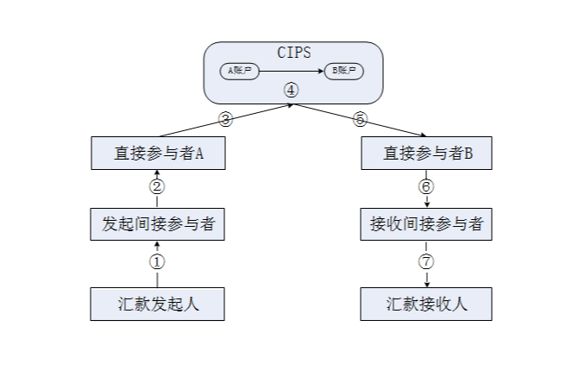

Initiator

Direct Participant B

Receiving Indirect Participant

Receiver

Initiating Indirect Participant

Direct Participant A

Account B

Account A

The process of customer credit transfer is as follows:

①Initiator submits a request for remittance to Initiating Indirect Participant.

② Initiating Indirect Participant sends a payment order to Direct Participant A.

③ Direct Participant A sends a CustomerCreditTransfer message conforming to CIPS’ payment order format requirements to CIPS.

④ Upon receiving the message, CIPS performs message format check, necessary business checks (including digital signature check) and double accounting check; after the message passes the checks, CIPS debits the fund account of Direct Participant A and credits the fund account of Direct Participant B.

If the transaction has been cleared, CIPS notifies Direct Participant A through a SettlementConfirmation message.

If the transaction has been included into pending, CIPS notifies Direct Participant A through a SettlementConfirmation message.

If Direct Participant A fails to receive a SettlementConfirmation message from CIPS, Direct Participant A can send a PaymentStatusQuery message to CIPS for query.

If the transaction has not been settled by CIPS business cut-off, CIPS returns the transaction and notifies Direct Participant A.

⑤ After fund settlement, CIPS sends a CustomerCreditTransfer message to Direct Participant B.

⑥ Direct Participant B sends a payment order to Receiving Indirect Participant.

⑦ Receiving Indirect Participant unfreezes corresponding fund to Receiver

CIPS does not set any payment return message or type. Please refer to the above process for the payment return process of customer credit transfer.

* 1. Financial Institution Transfer

Financial institution transfer is shown in the figure below:

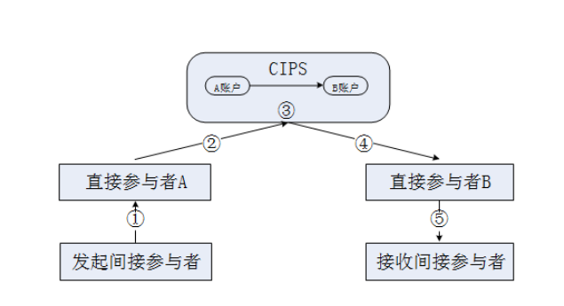

Initiating Indirect Participant

Receiving Indirect Participant

Direct Participant B

Direct Participant A

Account B

Account A

The process of financial institution transfer is as follows:

① Initiating Indirect Participant sends a payment order to Direct Participant A.

② Direct Participant A sends a FinancialInstitutionTransfer message conforming to CIPS’ payment order format requirements to CIPS.

③ Upon receiving the message, CIPS performs message format check, necessary business checks (including digital signature check) and double accounting check; after the message passes the checks, CIPS debits the fund account of Direct Participant A, and credits the fund account of Direct Participant B.

If the transaction has been cleared, CIPS notifies Direct Participant A through a SettlementConfirmation message.

If the transaction has been included into pending, CIPS notifies Direct Participant A through a SettlementConfirmation message.

If Direct Participant A fails to receive a SettlementConfirmation message from CIPS, Direct Participant A can send a PaymentStatusQuery message to CIPS for query.

If the transaction has not been settled by CIPS business cut-off, CIPS returns the transaction and notifies Direct Participant A.

④ After fund settlement, CIPS sends a FinancialInstitutionTransfer message to Direct Participant B.

⑤ Direct Participant B sends a payment order to Receiving Indirect Participant.

Please refer to the above process for the payment return process of financial institution transfer.

* 1. Batch Customer Payment

Batch customer payment is shown in the figure below:

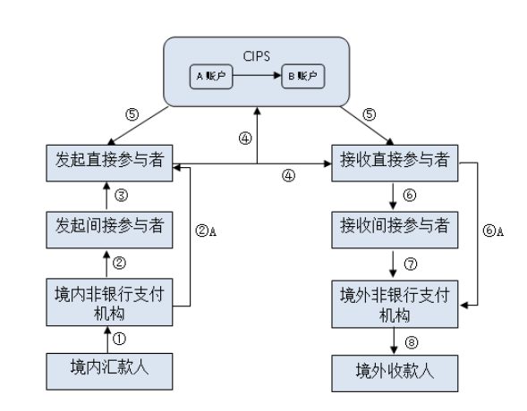

Overseas Non-bank Payment Institution

Domestic Non-bank Payment Institution

Domestic Creditor

Domestic Debtor

Receiving Indirect Participant

Initiating Indirect Participant

Initiating Direct Participant

Receiving Direct Participant

Account B

Account A

The process of batch customer payment is as follows:

① Domestic Debtor submits a request for remittance to Debtor Agent or Domestic Non-bank Payment Institution.

② Upon receiving the request for remittance, Debtor Agent or Domestic Non-bank Payment Institution sends a Payment message to Initiating Indirect Participant (②A If Debtor Agent or Domestic Non-bank Payment Institution has opened an account at a Direct Participant, the Payment message will be directly sent to Initiating Direct Participant).

③ Upon receiving the Payment message, Initiating Indirect Participant directly forwards the Payment message to Initiating Direct Participant.

④ Upon receiving the Payment message, Initiating Direct Participant packs the message and determines the bilateral initiator limit for net settlement; if the total amount of the packed transactions is less than the bilateral initiator limit for net settlement, Initiating Direct Participant should send the Packet message to CIPS and Receiving Direct Participant through Payment Message Transmission Platform (PMTS); if the total amount of the packed transactions is more than the bilateral initiator limit for net settlement, Initiating Direct Participant should not send the Packet message to any other party.

⑤ Upon receiving the Packet message, CIPS performs business checks on the packed transactions; after the packed transactions pass these checks, CIPS includes the whole packet of transactions into a common queue, and sends a “Netted” notice to Initiating Direct Participant and Receiving Direct Participant.

The checking content includes message format, double accounting, expected settlement date, Initiating/ReceivingDirectParticipantIdentification in packet header, CIPS system status, business authority, logging status, signature verification, inner-packet single transaction amount, consistency between TotalInterbankSettlementAmount in packet header and aggregate amount, consistency between NumberOfTransactions in packet header and transacions of subsidiary payments, indirect participant status, relation between indirect and direct participants, capital injection status, freezing status, and bilateral limit. The checking items can increase or decrease according to the business conditions.

⑥ Upon receiving a Payment message or Netting notice, Receiving Direct Participant can carry out accounting treatment and then send the Payment message to Receiving Indirect Participant. (⑥A If Creditor Agent or Overseas Non-bank Payment Institution has opened an account at Receiving Direct Participant, Receiving Direct Participant directly sends the Payment message to Creditor Agent or Overseas Non-bank Payment Institution).

⑦ Receiving Indirect Participant sends the Payment message to Creditor Agent or Overseas Non-bank Payment Institution.

⑧ Creditor Agent or Overseas Non-bank Payment Institution unfreezes corresponding fund to Overseas Creditor.

By the time of netting, CIPS executes fund settlement and send a “Settlement Success” notice to Initiating Direct Participant and Receiving Direct Participant. Receiving Direct Participant may also unfreeze the fund after receiving a “Settlement” notice from CIPS.

1. Description of BusinessActivities

This section presents the different BusinessActivities within each BusinessProcess. The BusinessActivities of a process are described with an activity diagram. The following is an introduction to the activity diagram.

describes the general lifecycle of a business process;

Start Point ⚫ shows where the lifecycle of the business process commences, and End Point  shows where the lifecycle of the business process may end;

Lozenge (or Diamond) indicates that a choice between several actions can be made;

There are activity streamlines between Participants;

Information in the BusinessActivities is transmitted from a Participant to another.

* 1. Customer Credit Transfer/Financial Institution Transfer
     1. Normal Scenario of Customer Credit Transfer

Initiating Direct Participant sends a CustomerCreditTransfer/FinancialInstitutionTransfer message to CIPS; upon receiving the message, CIPS performs message format check and double accounting check. If the message fails to pass message format check and double accounting check, CIPS will reject to process the message, abandon the message, and send a “MessageAbandonNotice” message to Central Counterparty, prompting that the message cannot be identified; after the message passes message format check and double accounting check, CIPS will perform business checks. If the message fails to pass business legality check and digital signature validity check, CIPS will reject the message, and send an “AnswerForCCP” message to inform Central Counterparty of the error causes; after the message passes the checks, CIPS will look over the pending flag and judge whether it is pending for settlement. If the flag is pended, CIPS will execute fund settlement; if the flag is pending, CIPS will not execute fund settlement until the pending ends; if the business has not yet been settled at day end, CIPS will execute end-of-day return. In case of pending for settlement or end-of-day return, the business processing results will be returned to Initiating Direct Participant through a SettlementConfirmation message. After fund settlement, CIPS forwards the CustomerCreditTransfer/FinancialInstitutionTransfer message to Receiving Direct Participant in real time, and returns the business processing results to Initiating Direct Participant through a SettlementConfirmation message.

Pass message format check and double accounting check or not

Check whether there is a pending flag

Send the Remittance message to Receiving Direct Participant

Send a SettlementConfirmation message to Initiating Direct Participant

(Pending settlement fails at day end) End-of-day returned

Pass business legality check and digital signature validity check or not

Send a MessageAbandon Notice message

Send a Settlement Confirmation message

Receive the Settlement Confirmation message

Receive the MessageAbandon Notice message

No

Yes

Yes

Yes

No

No

Settled

Receive the Remittance message

Pending for settlement

Message review

Receive the Remittance message

Send a Remittance message to CIPS

Receiving Direct Participant

Initiating Direct Participant



* + 1. Special Scenario of Customer Credit Transfer

In the Pending status, Initiating Direct Participant can send a PaymentCancellation message to CIPS, and CIPS will reply to Initiating Direct Participant with an AnswerForPaymentCancellation message to complete the payment cancellation.

Send a AnswerForPaymentCancellation message

Receive the AnswerForPaymentCancellation message

Receive the PaymentCancellation message

Initiating Direct Participant

Send a PaymentCancellation message to CIPS



* 1. Batch Customer Payment

Initiating Direct Participant sends a Payment message to Receiving Direct Participant; upon receiving the message, CIPS performs message format check and double accounting check. If the message fails to pass message format check and double accounting check, CIPS will reject to process the message, abandon the message, and send a “MessageAbandonNotice” message to Central Counterparty, indicating that the message cannot be identified; after the message passes message format check and double accounting check, CIPS will perform business legality check and digital signature validity check. If the message fails to pass business legality check and digital signature validity check, CIPS will reject the message, and send an “AnswerForCCP” message to inform Central Counterparty of the error causes; after the message passes business legality check and digital signature validity check, CIPS will send a SettlementConfirmation message to Initiating Direct Participant and Receiving Direct Participant.

Send a SettlementConfirmation message to Initiating/Receiving Direct Participant

Pass business legality check and digital signature validity check or not

Yes

No

No

Receiving Direct Participant

Receive the Remittance message

Receive the MessageAbandonNotice message

Receive the SettlementConfirmation message

Send a MessageAbandonNotice message

Pass message format check and double accounting check or not

Receive the Remittance message

Receive the SettlementConfirmation message

Receive the MessageAbandonNotice message

Send a Remittance message to Receiving Direct Participant/CIPS

Initiating Direct Participant



1. BusinessProcesses

This section describes the message flows based on the following activity diagrams so as to show the specific communication processes in the BusinessProcesses or BusinessTransactions.

* 1. Customer Credit Transfer

Initiating Direct Participant sends a Remittance message to CIPS; after fund settlement, CIPS forwards it to Receiving Direct Participant in real time, and returns the business processing results to Initiating Direct Participant through a SettlementConfirmation message.

* + 1. Normal Process of Customer Credit Transfer

The business initiated by a Participant is settled smoothly.

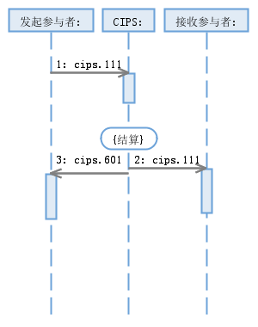

{Settled}

Receiving Participant:

Initiating Participant:

The business initiated by a Participant is settled after pending for settlement.

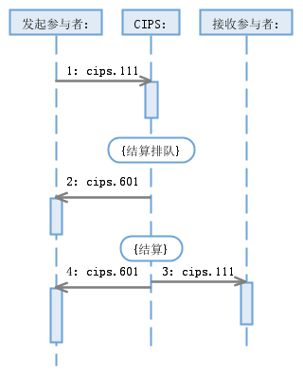

{Pending for settlement}

{Pending for settlement}

{Settled}

Receiving Participant:

Initiating Participant:

* + 1. Special Process of Customer Credit Transfer

The business initiated by a Participant is cancelled in the process of pending for settlement.

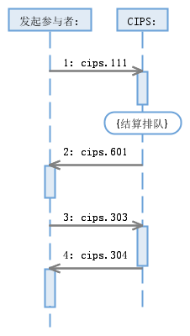

Initiating Participant

If the business initiated by a Participant has not yet been settled or cancelled at day end after pending for settlement, CIPS will return the business.

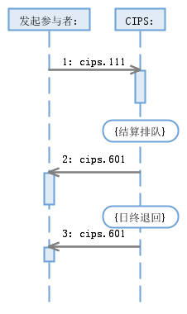

Initiating Participant

{End-of-day returned}

{Pending for settlement}

The business initiated by a Participant is rejected by CIPS due to the error(s) founds in business checks.

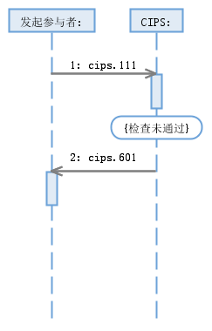

{Failure to pass the checks}

Initiating Participant

CIPS abandons a message sent by a Participant due to nonexistence of DirectParticipantIdentification, invalid DirectParticipantIdentification, wrong message format or double accounting.

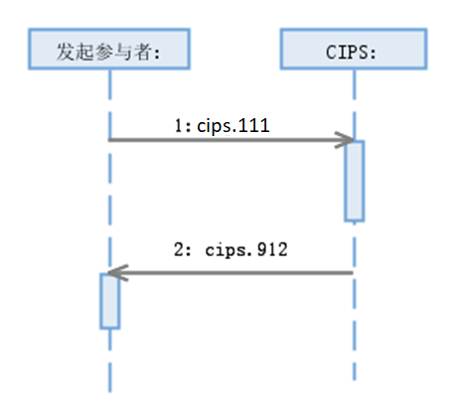

Initiating Participant:

* 1. Financial Institution Transfer

When the business only involves the accounts of financial institutions, Initiating Direct Participant sends a Remittance message to CIPS; after fund settlement, CIPS forwards the message to Receiving Direct Participant in real time, and returns the business processing results to Initiating Direct Participant through a SettlementConfirmation message.

* + 1. Normal Process of Financial Institution Transfer

The business initiated by a Participant is settled smoothly.

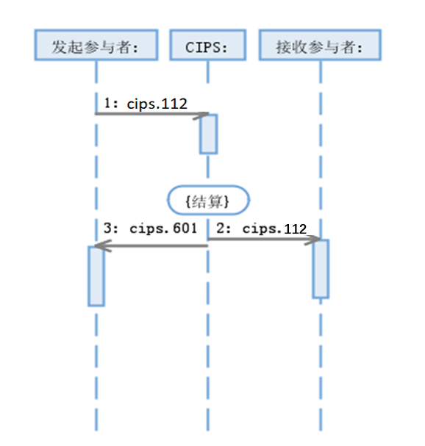

{Settled}

Receiving Participant:

Initiating Participant:

The business initiated by a Participant is settled after pending for settlement.

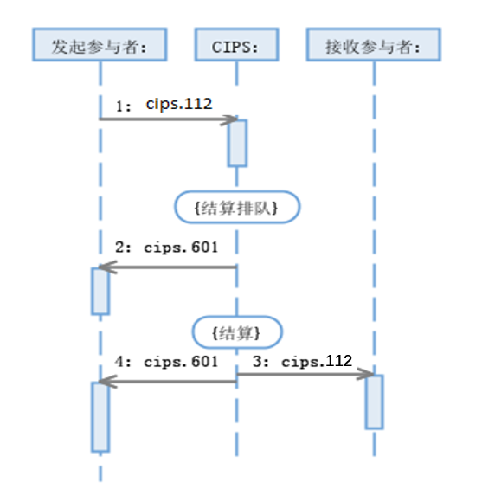

{Pending for settlement}

{Settled}

Receiving Participant

Initiating Participant

* + 1. Special Process of Financial Institution Transfer

The business initiated by a Participant is cancelled in the process of pending for settlement.

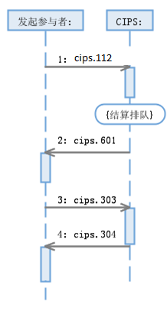

Initiating Participant

{Pending for settlement}

If the business initiated by a Participant has not yet been settled or cancelled at day end after pending for settlement, CIPS will return the business.

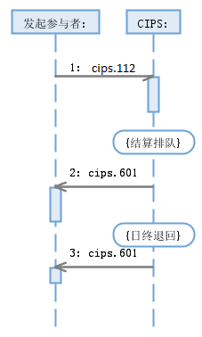

{End-of-day returned}

{Pending for settlement}

Initiating Participant

The business initiated by a Participant is rejected by CIPS due to the error(s) founds in business checks.

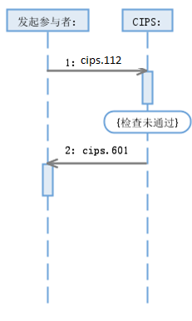

Initiating Participant:

{Failure to pass the checks}

CIPS abandons a message sent by a Participant due to nonexistence of DirectParticipantIdentification, invalid DirectParticipantIdentification, wrong message format or double accounting.

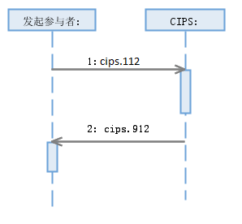

Initiating Participant

* 1. Batch Customer Payment

Initiating Direct Participant sends a BatchCustomerPayment message to Receiving Direct Participant; after business checking and payment status confirmation, CIPS sends a SettlementConfirmation message to Initiating Direct Participant and Receiving Direct Participant.

* + 1. Normal Process of Batch Customer Payment

If the business initiated by a Participant passes the business checks smoothly or CIPS business checks fail, corresponding success or rejection processing is carried out.

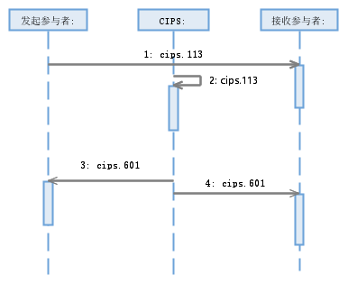

Receiving Participant:

Initiating Participant:

* + 1. Special Process of Batch Customer Payment

CIPS abandons a BatchCustomerPayment message sent by a Participant due to nonexistence of DirectParticipantIdentification, invalid DirectParticipantIdentification, unfound original business, wrong message format or double accounting.

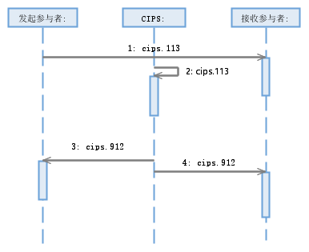

Receiving Participant

Initiating Participant

1. Example
   1. CustomerCreditTransfer <cips.111.001.02>

**Message Instance:**

<FIToFICstmrCdtTrf>

<GrpHdr>

<MsgId>2017121161212237</MsgId>

<CreDtTm>2017-12-11T09:30:47</CreDtTm>

<NbOfTxs>1</NbOfTxs>

<SttlmInf>

<SttlmMtd>CLRG</SttlmMtd>

</SttlmInf>

</GrpHdr>

<CdtTrfTxInf>

<PmtId>

<EndToEndId>DB00005800000001</EndToEndId>

<TxId>2017121161212237</TxId>

</PmtId>

<PmtTpInf>

<CtgyPurp>

<Prtry>GODX</Prtry>

</CtgyPurp>

</PmtTpInf>

<IntrBkSttlmAmt Ccy="CNY">5000.00</IntrBkSttlmAmt>

<IntrBkSttlmDt>2017-12-11</IntrBkSttlmDt>

<SttlmPrty>URGT</SttlmPrty>

<InstdAmt Ccy="CNY">5000.00</InstdAmt>

<ChrgBr>CRED</ChrgBr>

<ChrgsInf>

<Amt Ccy="CNY">40.00</Amt>

<Agt>

<FinInstnId>

<ClrSysMmbId>

<MmbId>CMBCCNBSXXX</MmbId>

</ClrSysMmbId>

</FinInstnId>

</Agt>

</ChrgsInf>

<InstgAgt>

<FinInstnId>

<ClrSysMmbId>

<MmbId>PCBCCNBJXXX</MmbId>

</ClrSysMmbId>

</FinInstnId>

<BrnchId>

<Id>PCBCHKHHXXX</Id>

</BrnchId>

</InstgAgt>

<InstdAgt>

<FinInstnId>

<ClrSysMmbId>

<MmbId>CMBCCNBSXXX</MmbId>

</ClrSysMmbId>

</FinInstnId>

<BrnchId>

<Id>CMBCHKHHXXX</Id>

</BrnchId>

</InstdAgt>

<IntrmyAgt1>

<FinInstnId>

<ClrSysMmbId>

<MmbId>CITICNSXBJG</MmbId>

</ClrSysMmbId>

<Nm>Citibank (China) Co., Ltd., Beijing Branch</Nm>

</FinInstnId>

</IntrmyAgt1>

<IntrmyAgt2>

<FinInstnId>

<ClrSysMmbId>

<MmbId>HASECNSHBEJ</MmbId>

</ClrSysMmbId>

<Nm>Hang Seng Bank, Beijing Branch</Nm>

</FinInstnId>

</IntrmyAgt2>

<Dbtr>

<Nm>Xiao-Hua</Nm>

<PstlAdr>

<AdrLine>No. 12, Zizhuyuan Road, Haidian District, Beijing, China</AdrLine>

</PstlAdr>

<Id>

<OrgId>

<Othr>

<Id>185416165</Id>

</Othr>

</OrgId>

</Id>

<CtryOfRes>JP</CtryOfRes>

</Dbtr>

<DbtrAcct>

<Id>

<Othr>

<Id>123456</Id>

</Othr>

</Id>

</DbtrAcct>

<DbtrAgt>

<FinInstnId>

<ClrSysMmbId>

<MmbId>5QWSQD55</MmbId>

</ClrSysMmbId>

<Nm>DebtorAgentName</Nm>

<PstlAdr>

<AdrLine>No. 182, Lujiazui East Road, Pudong New District, Shanghai, China</AdrLine>

</PstlAdr>

</FinInstnId>

</DbtrAgt>

<DbtrAgtAcct>

<Id>

<Othr>

<Id>6181651848</Id>

</Othr>

</Id>

</DbtrAgtAcct>

<CdtrAgt>

<FinInstnId>

<ClrSysMmbId>

<MmbId>QWEDWDFS1454</MmbId>

</ClrSysMmbId>

<Nm>CreditorAgentName</Nm>

<PstlAdr>

<AdrLine>No. 181, Lujiazui East Road, Pudong New District, Shanghai, China</AdrLine>

</PstlAdr>

</FinInstnId>

</CdtrAgt>

<CdtrAgtAcct>

<Id>

<Othr>

<Id>6196541986511</Id>

</Othr>

</Id>

</CdtrAgtAcct>

<Cdtr>

<Nm>Liu</Nm>

<PstlAdr>

<AdrLine>No. 288, Lai-An Road, Pudong New District, Shanghai, China</AdrLine>

</PstlAdr>

<Id>

<PrvtId>

<Othr>

<Id>2145555555</Id>

<SchmeNm>

<Prtry>PSPT</Prtry>

</SchmeNm>

</Othr>

</PrvtId>

</Id>

<CtryOfRes>CN</CtryOfRes>

</Cdtr>

<CdtrAcct>

<Id>

<Othr>

<Id>2222333344445555</Id>

</Othr>

</Id>

</CdtrAcct>

<InstrForCdtrAgt>

<InstrInf>Payment of CNY 5,000.00 for Goods on 10 Decemeber 2017</InstrInf>

</InstrForCdtrAgt>

<RgltryRptg>

<Dtls>

<Tp>415</Tp>

<Inf>adwgvascc</Inf>

</Dtls>

</RgltryRptg>

<RmtInf>

<Ustrd>Payment of CNY 5,000.00 for Goods on 10 Decemeber 2017</Ustrd>

</RmtInf>

<SplmtryData>

<PlcAndNm>/Document/FIToFICstmrCdtTrf/CdtTrfTxInf</PlcAndNm>

<Envlp>

<Cnts>

<XpctdSttlmDt>2017-12-11</XpctdSttlmDt>

<DEId>151854165</DEId>

<CEId>165385411</CEId>

</Cnts>

</Envlp>

</SplmtryData>

</CdtTrfTxInf>

</FIToFICstmrCdtTrf>