

CIPS Message Definition Report
Part 1: Clearing and Settlement—Financial Market Fund Settlement

V1.0.0
January 2021

Important Note: This Article is made out in both English and Chinese versions. We hereby set Chinese version as standard and English version as a reference should any conflicts occurred. If you have any questions, please contact us at bzb@cips.com.cn.

Revision Record
Version Number | Date | Revision Note | Scope
V1.0.0 | 26-10-2019 | [C]  CIPS Message Definition Report — Part 1: Financial Market Fund Settlement | All
Note: Change statuses are C — created, A — added, M — modified, and D — deleted.
Table of Contents

1 Introduction 1
1.1 Terms and Definitions 1
1.2 Abbreviations and Acronyms 2
1.3 Document Scope and Objectives 2
1.4 References 2
2 Scope and Functionality 2
2.1 Background 2
2.2 Scope 2
2.3 Groups of MessageDefinitions and Functionality 3
3 BusinessRoles and Participants 3
3.1 Financial Market Fund Settlement 3
4 BusinessProcess Description 4
4.1 Settlement Initiated by a Direct Participant Bank 4
4.2 Settlement Initiated by a Direct Participant FMI 5
5 Description of BusinessActivities 5
5.1 Securities Settlement System by Bank/Answer for SSS by Bank 6
5.1.1 Normal Scenario of Securities Settlement System by Bank 6
5.1.2 Special Scenario of Securities Settlement System by Bank 7
5.2 Securities Settlement System by FMI/Answer for SSS by FMI 8
5.2.1 Normal Scenario of Securities Settlement System by FMI 8
5.2.2 Special Scenario of Securities Settlement System by FMI 10
6 BusinessProcesses 11
6.1 Securities Settlement System by Bank/Answer for SSS by Bank 12
6.1.1 Normal Securities Settlement System by Bank/Answer for SSS by Bank 12
6.1.2 Special Securities Settlement System by Bank/Answer for SSS by Bank 12
6.2 Securities Settlement System by FMI/Answer for SSS by FMI 14
6.2.1 Normal Process of Securities Settlement System by FMI 14
6.2.2 Special Process of Securities Settlement System by FMI 15
7 Example 20
7.1 SecuritiesSettlementSystemByBank <cips.133.001.01> 20

- Introduction
  - Terms and Definitions
The terms involved in this document are defined as follows:
Term | Definition
BusinessRole | A BusinessRole represents an entity (or a class of entities) of an actual business.
Participant | A functional role played by a BusinessRole in a particular BusinessProcess or BusinessTransaction.
BusinessProcess | Business activities undefined but undertaken within a BusinessArea whereby each BusinessProcess fulfills one type of business activities and whereby a BusinessProcess may include and extend other BusinessProcesses.
BusinessTransaction | A particular solution that meets the communication requirements and the interaction requirements of a particular BusinessProcess and BusinessArea.
MessageDefinition | Formal description of the structure of a message instance.

The CIPS terms involved in this document are defined as follows:
Term | Description
Cross-border Interbank Payment System (CIPS) | CIPS provides fund clearing and settlement service for its Participants’ cross-border RMB payment transactions, financial market transactions, etc.
The 2nd generation of China National Advanced Payment System (CNAPS2) | An electronic system built, operated and maintained by the General Clearing Center of the People’s Bank of China for handling the fund transfer among financial institutions nationwide, including high value payment system (HVPS), bulk electronic payment system (BEPS), internet banking payment system (IBPS), common control system (CCS), and other subsystems.
CIPS Direct Participant | CIPS Direct Participant refers to a domestic or an overseas institution that has a CIPS code and handles cross-border RMB payment and settlement businesses directly through CIPS. The operating agency of CIPS will open a CIPS account for each Direct Participant bank, and will also open a CIPS account for each Direct Participant FMI as required by prudent management.
CIPS Indirect Participant | CIPS Indirect Participant refers to a domestic or an overseas institution that has not opened a CIPS account but has a CIPS code and entrusts an appropriate CIPS Direct Participant to handle cross-border RMB payment and settlement businesses through CIPS.
Initiator | Initiator refers to an individual or institution that initially creates a payment or information request.
Receiver | Receiver refers to an individual or institution that ultimately receives a payment or information request.
DvP/PvP Settlement | CIPS supports DvP (Delivery Versus Payment) settlement and PvP (Payment Versus Payment) settlement. DvP/PvP settlement can be initiated by a bank or FMI as a direct participant.

  - Abbreviations and Acronyms
Abbreviation/Acronyms | Definition
CIPS | Cross-border Interbank Payment System
SSS | Securities Settlement System
FMI | Financial Market Infrastructure

  - Document Scope and Objectives
This document is the first part of the Remittance Message Definition Report (MDR) and describes the BusinessTransactions and underlying message set. For the sake of completeness, the document may also describe the BusinessActivities that are not in the scope of the BusinessProcesses covered in this document.
This document describes the following:
- the BusinessProcesses scope
- the BusinessRoles involved in these BusinessProcesses
The main objectives of this document are as follows:
- to explain the BusinessProcesses and BusinessActivities these messages have addressed
- to explain the BusinessProcesses and BusinessActivities these messages have addressed
- to give a high-level description of the BusinessProcesses and associated BusinessRoles
- to explain the BusinessProcesses and related Participants
- to present a list of MessageDefinitions
  - References
Document | Version | Date | Author
Message Exchange Standard for CNAPS2 | V1.4.7 | 05-2017 | China National Clearing Center, the People’s Bank of China
CIPS (Phase II) Requirements Specification | V1.0.0 | 05-2017 | China National Clearing Center, the People’s Bank of China
CIPS Message Exchange Standard V2.1.0 | V2.1.0 | 11-01-2019 | Payment System Development Center, China National Clearing Center, the People’s Bank of China
Requirements Specification for Multi-debit/credit Transfer by Clearing Institution | V0.5.0 | 01-2019 | China National Clearing Center, the People’s Bank of China
- Scope and Functionality
  - Background
This Message Definition Report covers a set of 9 messages developed by CIPS for financial market fund settlement.
  - Scope
This message set covers the BusinessProcesses of financial market fund settlement. The following 9 messages are used to describe the BusinessProcesses:
- SecuritiesSettlementSystemByBank (cips.133.001.01): Debtor Direct Participant Bank sends this message to CIPS; after fund processing, CIPS will forward cips.133 to Trade Settlement System and Creditor Direct Participant Bank.
- AnswerForSSSByBank(cips.134.001.01):Upon receiving cips.133 forwarded by CIPS, Trade Settlement System sends a cips.134 to CIPS with confirmation or rejection of the settlement.
- SecuritiesSettlementSystemByFMI (cips.135.001.01): After a financial market transaction enters settlement, Trade Settlement System will send this message to CIPS; after corresponding processing, CIPS forwards cips.135 to Debtor Direct Participant Bank and Creditor Direct Participant Bank.
- AnswerForSSSByFMI (cips.136.001.01): Upon receiving cips.135 forwarded by CIPS, Debtor Direct Participant Bank sends cips.136 with confirmation or rejection of the payment.
- PaymentCancellation (cips.303.001.01): Initiator sends cips.303 to CIPS to cancel the previous payment.
- AnswerForPaymentCancellation (cips.304.001.01): CIPS replies cips.304 to Initiator for payment cancellation.
- SettlementConfirmation (cips.601.001.02): After the BusinessProcessStatus has changed (RJCT, ACSC, PDNG, EDRN), CIPS sends cips.601 to notify the related Participants.
- CommonConfirmation (cips.900.001.01): Upon receiving a message from a Participant, CIPS replies with the processing result in cips.900, or vice versa.
- MessageAbandonNotice (cips.912.001.01): CIPS sends a cips.912 to abandon received message if CIPS can neither carry out any business processing nor reply with a business-level CommonConfirmation message.
  - Groups of MessageDefinitions and Functionality
MessageDefinition | ISO 20022 Identifier | CIPS Identifier
SecuritiesSettlementSystemByBank | sese.023.001.06 | cips.133.001.01
AnswerForSSSByBank | sese.040.001.02 | cips.134.001.01
SecuritiesSettlementSystemByFMI | sese.023.001.06 | cips.135.001.01
AnswerForSSSByFMI | sese.040.001.02 | cips.136.001.01
PaymentCancellation | camt.008.001.05 | cips.303.001.01
AnswerForPaymentCancellation | pacs.002.001.05 | cips.304.001.01
SettlementConfirmation | pacs.002.001.05 | cips.601.001.02
CommonConfirmation | / | cips.900.001.01
MessageAbandonNotice | / | cips.912.001.01
- BusinessRoles and Participants
A BusinessRole represents an entity (or a class of entities) of the real world, physical or legal, including a person or corporation. Examples of BusinessRoles: “Financial Institution”, and so on.
A Participant is a functional role played by a BusinessRole in a particular BusinessProcess or BusinessTransaction. Examples of Participants: the “user” of a system, “debtor”, “investor”, and so on.
The relationship between BusinessRoles and Participants is many-to-many. A BusinessRole can act as different Participants at different moments or at the same time. For example, a BusinessRole can be the “user” of a system, a “debtor” and an “investor” at the same time. In addition, different BusinessRoles can be involved as the same Participant.
  - Financial Market Fund Settlement
The BusinessRoles and Participants in financial market fund settlement are described below.
Participant and BusinessRole Definitions
Participant | Definition
CIPS | Cross-border Interbank Payment System
Debtor Direct Participant Bank | A domestic or an overseas banking institution accepting the fund settlement services provided by CIPS as a direct participant on behalf of debtor.
Creditor Direct Participant Bank | A domestic or an overseas banking institution accepting the fund settlement services provided by CIPS as a direct participant on behalf of creditor.
SSS | Securities Settlement System
BusinessRole | Definition
CIPS Participant | A participant that directly interacts with CIPS
Clearing System | Cross-border Interbank Payment System

Participant and BusinessRole Matrix
BusinessRole  Participant | CIPS Participant | Clearing System
CIPS |  | √
Debtor Direct Participant Bank | √
Creditor Direct Participant Bank | √
SSS | √

- BusinessProcess Description
This section describes the BusinessProcesses. Description of the BusinessProcesses and the information in the BusinessProcesses can help to identify relationships between the BusinessRoles.
  - Settlement Initiated by a Direct Participant Bank
The following figure shows the BusinessProcess of settlement initiated by a Direct Participant Bank.
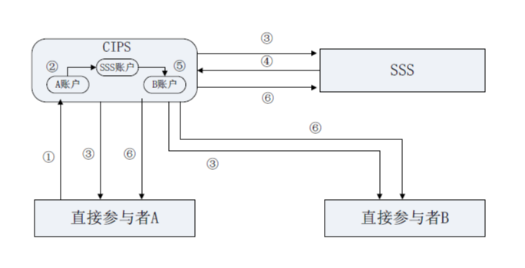
Account A
Account B
SSS account
Direct Participant A
Direct Participant B
The BusinessProcess is as follows:
① Direct Participant A sends a FinancialMarketBusiness message containing financial market transaction information and specifying settlement-related SSS to CIPS.
② Upon receiving the message from Direct Participant A, CIPS checks the account balance of Direct Participant A; if the balance is insufficient, CIPS rejects the message; if the balance is sufficient, CIPS transfers the transaction amount into the account of SSS at CIPS for temporary deposit.
③ After processing, CIPS respectively informs Direct Participant A, Direct Participant B and SSS.
④ SSS matches the payment information with the bond trading information, freezes Direct Participant B’s bond after confirming no error, and returns an answer to CIPS. If matching is wrong or insufficient bond of Direct Participant B leads to a freezing failure, SSS returns a “RJCT” answer to CIPS.
⑤ Upon receiving a “SUCD” answer, CIPS transfers the temporary deposit in SSS’s account from Direct Participant A’s account into Direct Participant B’s account.
⑥ CIPS respectively informs Direct Participant A, Direct Participant B and SSS of the processing result.
In addition, the temporary receipts of SSS settlement should be strictly separated from the payments related to CCP or CSD settlement, to ensure that they are independent from each other. The processing of SSS settlement should not affect the normal processing of CCP or CSD settlement.
  - Settlement Initiated by a Direct Participant FMI
The following figure shows the BusinessProcess of settlement initiated by a Direct Participant FMI.
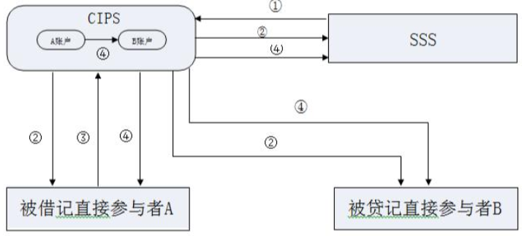
Account A
Account B
Debited Direct Participant A
Credited Direct Participant B

The BusinessProcess is as follows:
① SSS sends a FinancialMarketBusiness message containing financial market transaction information to CIPS.
② Upon receiving the FinancialMarketBusiness message from SSS, CIPS performs business checks and verifies digital signature; after the message passes the checks, CIPS forwards the message to debited Direct Participant A and credited Direct Participant B, and informs SSS that the original message has been forwarded.
③ Upon receiving the message, debited Direct Participant A returns a “ACPT” answer to CIPS if it consents unto the payment, or return a “RJCT” answer to CIPS if it rejects the payment.
④ Upon receiving the answer, CIPS views the responsive status in the message; in case of receiving a “ACPT” answer, CIPS transfers corresponding money in Direct Participant A’s account into Direct Participant B’s account. In case of receiving a “RJCT” answer, CIPS marks the business as RJPT. CIPS informs SSS, debited Direct Participant A and credited Direct Participant B of the processing result.
- Description of BusinessActivities
This section presents the different BusinessActivities within each BusinessProcess. The BusinessActivities of a process are described with an activity diagram. The following is an introduction to the activity diagram.
describes the general lifecycle of a business process;
Start Point  shows where the lifecycle of the business process commences, and End Point  shows where the lifecycle of the business process may end;
Lozenge (or Diamond) indicates that a choice between several actions can be made;

There are activity streamlines between Participants;
Information in the BusinessActivities is transmitted from a Participant to another.
  - Securities Settlement System by Bank/Answer for SSS by Bank
    - Normal Scenario of Securities Settlement System by Bank
Debtor Direct Participant Bank sends a SecuritiesSettlementSystemByBank message to CIPS; CIPS accepts the message after business legality check and digital signature validity check. CIPS forwards the message to Trade Settlement System and Creditor Direct Participant Bank after fund processing. Trade Settlement System executes information matching and confirmation. If information matching succeeds, Trade Settlement System replies to CIPS with an AnswerForSSSByBank message. After technical checks and business checks, CIPS executes settlement for the business and sends a notice to Debtor Direct Participant Bank, Creditor Direct Participant Bank and Trade Settlement System.
No
Send a SecuritiesSettlementSystemByBank message to CIPS
Debtor Direct Participant Bank
Yes
Trade Settlement System
Creditor Direct Participant Bank
Receive the MessageAbandonNotice message
Receive the CommonConfirmation message
Receive the SettlementConfirmation message
Send a SettlementConfirmation message to Debtor Direct Participant Bank, Trade Settlement System and Creditor Direct Participant Bank
Payment System correspondingly processes the message
Send a CommonConfirmation message

Yes
No
Send a MessageAbandonNotice message
Pass message format check and double accounting check or not
Pass business legality check and digital signature validity check or not
Receive the AnswerForSSSByBank message
Send a SecuritiesSettlementSystemByBank message to Trade Settlement System
Receive the SecuritiesSettlementSystemByBank message
Execute information matching and confirmation
Send a AnswerForSSSByBank message to CIPS
Send a MessageAbandonNotice message
Receive the SettlementConfirmation message
Receive the SettlementConfirmation message
Receive the SecuritiesSettlementSystemByBank message
Send a SecuritiesSettlementSystemByBank message to Creditor Agent
Payment System correspondingly processes the SecuritiesSettlementSystemByBank message
Send a CommonConfirmation message
Pass business legality check and digital signature validity check or not
Send a MessageAbandonNotice message
Pass message format check and double accounting check or not

Message review
Receive the SecuritiesSettlementSystemByBank message
No
Yes
Yes
No
    - Special Scenario of Securities Settlement System by Bank
If CIPS has not yet received an AnswerForSSSByBank message from Trade Settlement System at the NTCS phase, CIPS will execute end-of-day return and send a SettlementConfirmation message indicating “EDRN” to Debtor Direct Participant Bank, Creditor Direct Participant Bank and Trade Settlement System.
No
Send a SecuritiesSettlementSystemByBank message to CIPS
Ordering Institution
Yes
Trade Settlement System
Creditor Agent
Receive the MessageAbandonNotice message
Receive the CommonConfirmation message
Receive the SettlementConfirmation message
Send a SettlementConfirmation message to Debtor Direct Participant Bank, Trade Settlement System and Creditor Direct Participant Bank
Receive the SettlementConfirmation message
Receive the SettlementConfirmation message
Receive the SecuritiesSettlementSystemByBank message
Send a SecuritiesSettlementSystemByBank message
(Failure to receive the AnswerForSSSByBank message from Trade Settlement System) End-of-day returned
Send a SecuritiesSettlementSystemByBank message to Creditor Agent/Trade Settlement System
Payment System conduct corresponding processing of the SecuritiesSettlementSystemByBank message
Send a CommonConfirmation message
Pass business legality check and digital signature validity check or not
Send a MessageAbandonNotice message
Receive the SecuritiesSettlementSystemByBank message

Message review
Pass message format check and double accounting check or not
No
Yes
Receive the SecuritiesSettlementSystemByBank message
Receive the SecuritiesSettlementSystemByBank message
  - Securities Settlement System by FMI/Answer for SSS by FMI
    - Normal Scenario of Securities Settlement System by FMI
Trade Settlement System sends a SecuritiesSettlementSystemByFMI message to CIPS; after technical checks and business checks, CIPS conducts corresponding processing and forwards the message to Debtor Direct Participant Bank and Creditor Direct Participant Bank, and sends a CommonConfirmation message to Trade Settlement System; upon receiving the SecuritiesSettlementSystemByFMI message, Debtor Direct Participant Bank replies to CIPS with an AnswerForSSSByFMI message; upon receiving the AnswerForSSSByFMI message, CIPS performs message format check and double accounting check to see whether there is a pending flag or whether the fund account balance is insufficient to make payment for the business; if there is no pending flag or the balance is sufficient, CIPS directly executes settlement; otherwise, CIPS executes pending for settlement; if the settlement fails at the end of the day, CIPS executes end-of-day return. After settlement and end-of-day return, CIPS replies to Trade Settlement System, Debtor Direct Participant Bank and Creditor Direct Participant Bank with a SettlementConfirmation message.
No
Send a SecuritiesSettlementSystemByFMI message to CIPS

Trade Settlement System
Yes
Debtor Direct Participant Bank
Creditor Direct Participant Bank
Receive the MessageAbandonNotice message
Receive the CommonConfirmation message
Receive the SecuritiesSettlementSystemByFMI message

Message review
Pass message format check and double accounting check or not
Pass business legality check and digital signature validity check or not
Send a CommonConfirmation message
CIPS correspondingly processes the SecuritiesSettlementSystem ByFMI message
Send a MessageAbandonNotice message
Yes
No
Send the SecuritiesSettlementSystem ByFMI message to Creditor Direct Participant Bank
Send the SecuritiesSettlementSystemByFMI message to Debtor Direct Participant Bank
Receive the AnswerForSSSByFMI message
Pass message format check and double accounting check or not
Send a MessageAbandonNotice message
Check whether there is a pending flag or whether the fund account balance is insufficient to make payment for the business

Pending for settlement
Yes
No
No
No
Yes
Yes
Settlement succeeds at the end of the day or not

End-of-day returned

Settled
Receive the SettlementConfirmation message
Send a SettlementConfirmation message to Trade Settlement System, Debtor Direct Participant Bank and Creditor Direct Participant Bank
Receive the SettlementConfirmation message
Receive the SettlementConfirmation message

Receive the SecuritiesSettlementSystemByFMI message
Receive the SecuritiesSettlementSystemByFMI message
Execute information matching and confirmation
Send a AnswerForSSSByFMI message to CIPS
Receive the MessageAbandonNotice message

    - Special Scenario of Securities Settlement System by FMI
The business initiated by Trade Settlement System is cancelled before CIPS receives an AnswerForSSSByFMI message from Debtor Direct Participant Bank.
No
Send a SecuritiesSettlementSystemByFMI message to CIPS
Trade Settlement System
Yes
Debtor Direct Participant Bank
Creditor Direct Participant Bank
Receive the MessageAbandonNotice message
Receive the CommonConfirmation message
Receive the CommonConfirmation message
Send a CommonConfirmation message to Trade Settlement System
CIPS correspondingly processes SecuritiesSettlementSystemByFMI message
Send a CommonConfirmation message
Pass business legality check and digital signature validity check or not
Send a MessageAbandonNotice message
Pass message format check and double accounting check or not

Message review
Receive the SecuritiesSettlementSystemByFMI message
No
Yes
Send the SecuritiesSettlementSystemByBank message to Payment/Collection Direct Participating Bank
Receive the PaymentCancellation message
Send a AnswerForPayment Cancellation message to Trade Settlement System
Send a SettlementConfirmation message to Payment/Creditor Direct Participant Bank
Receive the AnswerForPaymentCancellation message
(Before Debtor Direct Participant Bank sends an AnswerForSSSByFMI message) Send a PaymentCancellation message to Payment System
Receive the SecuritiesSettlementSystemByBank message
Receive the SettlementConfirmation message
Receive the SettlementConfirmation message
Receive the SecuritiesSettlementSystemByBank message

If Debtor Direct Participant Bank has any pending business or its fund account balance is insufficient to make payment for the business, settlement will not be executed until pending ends.
No
Send a SecuritiesSettlementSystemByFMI message to Payment System
Trade Settlement System
Yes
Debtor Direct Participant Bank
Creditor Direct Participant Bank
Receive the MessageAbandonNotice message
Receive the CommonConfirmation message
Send a CommonConfirmation message
Pass business legality check and digital signature validity check or not
Send a MessageAbandonNotice message
Pass message format check and double accounting check or not

Message review
Receive the SecuritiesSettlementSystemByFMI message
CIPS correspondingly processes the SecuritiesSettlementSystemByFMI message
Send the SecuritiesSettlementSystemByFMI message to Creditor Direct Participant Bank
Send the SecuritiesSettlementSystemByFMI message to Debtor Direct Participant Bank
Receive the AnswerForSSSByFMI message
Pass message format check and double accounting check or not
Send a MessageAbandonNotice message

Pending for settlement
Send a SettlementConfirmation message to Trade Settlement System, Debtor Direct Participant Bank and Creditor Direct Participant Bank
Receive the SettlementConfirmation message
Receive the SettlementConfirmation message
Receive the SettlementConfirmation message
Yes
No
No
Yes
(In the process of pending for settlement) Send a PaymentCancellation message to CIPS
Receive the AnswerForPaymentCancellation message
Receive the SecuritiesSettlementSystemByFMI message
Send an AnswerForPaymentCancellation message to Trade Settlement System
Send a SettlementConfirmation message to Payment/Creditor Direct Participant Bank
Receive the SettlementConfirmation message
Receive the SettlementConfirmation message
Receive the MessageAbandonNotice message
Send an AnswerForSSSByFMI message to CIPS
Execute information matching and confirmation
Receive the SecuritiesSettlementSystemByFMI message
Receive the SecuritiesSettlementSystemByFMI message

- BusinessProcesses
This section describes the message flows based on the following activity diagrams so as to show the specific communication processes in the BusinessProcesses or BusinessTransactions.
  - Securities Settlement System by Bank/Answer for SSS by Bank
CIPS accepts a SecuritiesSettlementSystemByBank message from Debtor Direct Participant Bank. CIPS forwards the message to Trade Settlement System and Creditor Direct Participant Bank after fund processing. Trade Settlement System executes information matching and confirmation. If information matching succeeds, Trade Settlement System replies to CIPS with an AnswerForSSSByBank message. CIPS executes settlement for the business and sends a notice to Debtor Direct Participant Bank, Creditor Direct Participant Bank and Trade Settlement System.
    - Normal Securities Settlement System by Bank/Answer for SSS by Bank
Debtor Direct Participant Bank sends a SecuritiesSettlementSystemByBank message to CIPS, and this message passes CIPS checks. CIPS forwards the message to Trade Settlement System and Creditor Direct Participant Bank after corresponding processing, and sends a CommonConfirmation message indicating “FRWD” to Debtor Direct Participant Bank; upon receiving the SecuritiesSettlementSystemByBank message forwarded by CIPS, Trade Settlement System executes information matching and confirmation. If information matching succeeds, CIPS sends a AnswerForSSSByBank message to CIPS (consenting unto or rejecting the business); upon receiving the answer from Trade Settlement System, whether the message passes the checks or business legality check, digital signature validity check and responsive status check fail, CIPS conducts corresponding processing and sends a SettlementConfirmation message to Debtor Direct Participant Bank, Creditor Direct Participant Bank and Trade Settlement System.
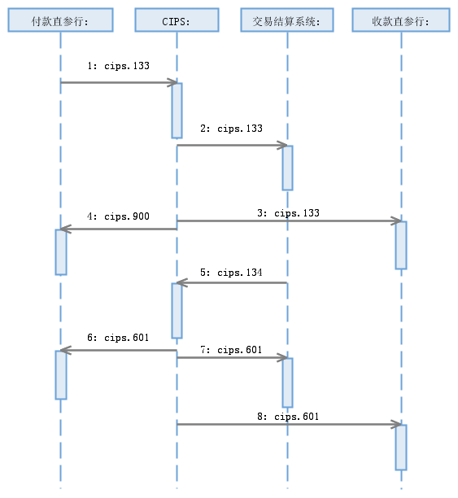
Debtor Direct Participant Bank:

Trade Settlement System:
Creditor Direct Participant Bank:
    - Special Securities Settlement System by Bank/Answer for SSS by Bank
CIPS abandons a SecuritiesSettlementSystemByBank message sent by Debtor Direct Participant Bank or a AnswerForSSSByBank message sent by Trade Settlement System due to nonexistence of DirectParticipantIdentification, invalid DirectParticipantIdentification, unfound original business, mismatching of Initiating Direct Participants with original Receiving Direct Participants, wrong current processing status of original FMI business, wrong message format or double accounting.
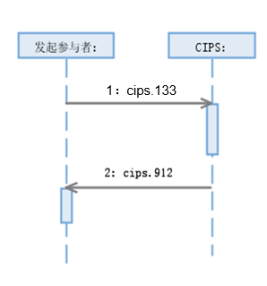
Initiating Participant:

CIPS rejects a SecuritiesSettlementSystemByBank message sent by Debtor Direct Participant Bank due to failure in business legality check or digital signature validity check or Ordering I’s balance insufficient to make payment for the business. CIPS sends a CommonConfirmation message indicating “RJCT” to inform Debtor Direct Participant Bank of the error causes.
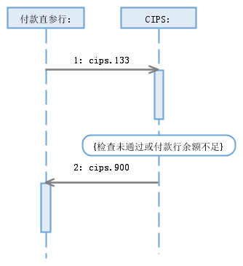
Debtor Direct Participant Bank:
{Failure to pass the checks or insufficient balance of Debtor Agent}

If CIPS has not yet received an AnswerForSSSByBank message from Trade Settlement System at the CLSG or NTCS phase, CIPS executes end-of-day return and sends a SettlementConfirmation message indicating “EDRN” to Debtor Direct Participant Bank, Creditor Direct Participant Bank and Trade Settlement System.
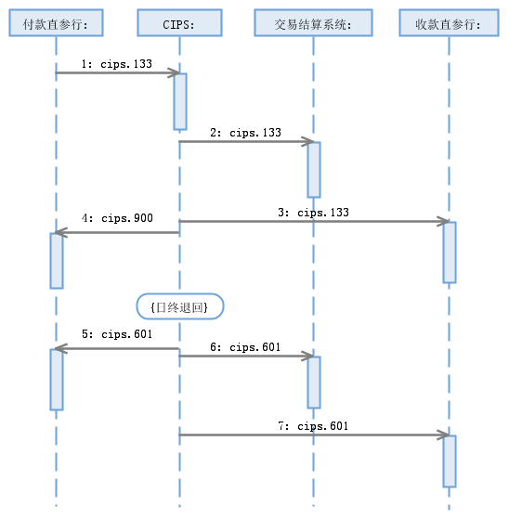
Debtor Direct Participant Bank:
Trade Settlement System:
Creditor Direct Participant Bank:
{end-of-day returned}

  - Securities Settlement System by FMI/Answer for SSS by FMI
Trade Settlement System sends a SecuritiesSettlementSystemByFMI message to CIPS when a financial market transaction enters settlement process. CIPS carries out fund delivery accordingly and feeds it back to Trade Settlement System, which will complete corresponding financial market transaction according to the feedback received.
    - Normal Process of Securities Settlement System by FMI
Trade Settlement System sends a SecuritiesSettlementSystemByFMI message to CIPS, and this message passes CIPS checks; after corresponding processing, CIPS forwards the message to Debtor Direct Participant Bank and Creditor Direct Participant Bank, and sends a CommonConfirmation message indicating “FRWD” to Trade Settlement System; upon receiving the SecuritiesSettlementSystemByFMI message, Debtor Direct Participant Bank replies to CIPS with a AnswerForSSSByFMI message (consenting unto or rejecting the payment); upon receiving the AnswerForSSSByFMI message, whether the message passes the business checks or business legality check and digital signature validity check fail, CIPS proceeds correspondingly and replies to Trade Settlement System, Debtor Direct Participant Bank and Creditor Direct Participant Bank with a SettlementConfirmation message.
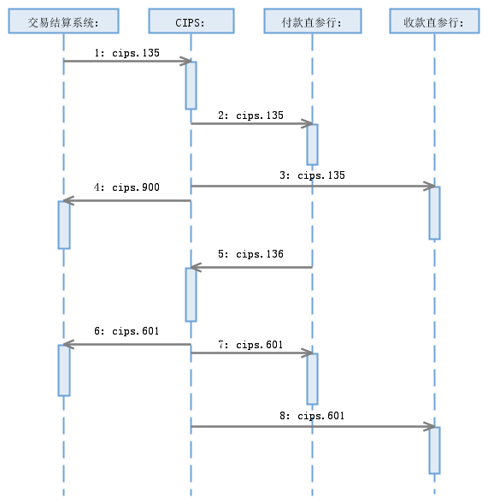
Trade Settlement System:
Debtor Direct Participant Bank:
Creditor Direct Participant Bank:
    - Special Process of Securities Settlement System by FMI
CIPS abandons a SecuritiesSettlementSystemByFMI message sent by Trade Settlement System or an AnswerForSSSByFMI message sent by Debtor Direct Participant Bank due to nonexistence of DirectParticipantIdentification, invalid DirectParticipantIdentification, unfound original business, mismatching of Initiating Direct Participant with original Receiving Direct Participant, wrong current processing status of original FMI business, message format error or double accounting.
Please refer to “MessageAbandonNotice” for the scenario

CIPS rejects a SecuritiesSettlementSystemByFMI message sent by Trade Settlement System due to failure in business legality check or digital signature validity check. CIPS sends a CommonConfirmation message indicating “RJCT” to inform Trade Settlement System of the error causes.
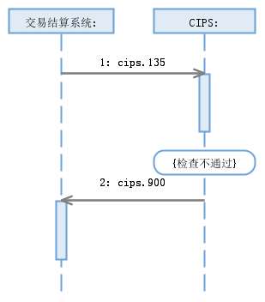
Trade Settlement System:
{Failure to pass the checks}

The business initiated by Trade Settlement System is cancelled before CIPS receives an AnswerForSSSByFMI message from Debtor Direct Participant Bank.
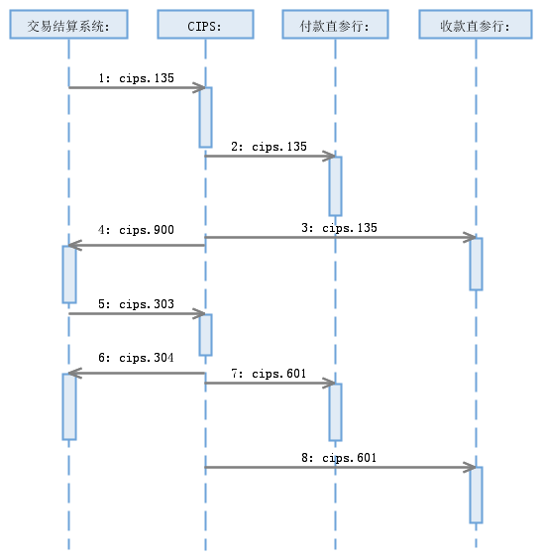
Trade Settlement System:
Debtor Direct Participant Bank:
Creditor Direct Participant Bank:

If Debtor Direct Participant Bank has any pending business or its account balance is insufficient to make payment for the business, settlement will not be executed until pending ends.
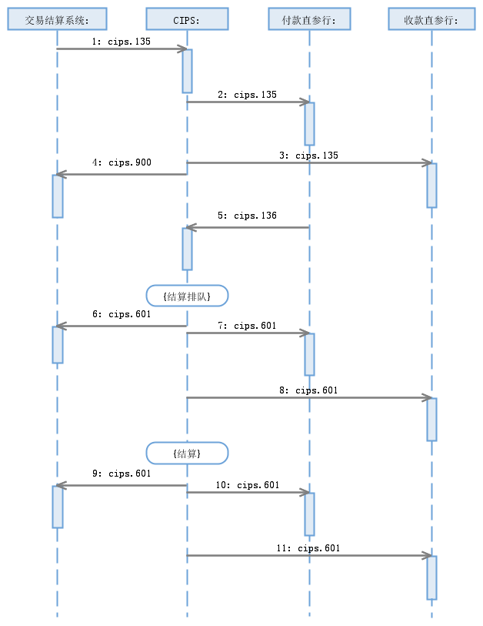
Trade Settlement System:
Debtor Direct Participant Bank:
Creditor Direct Participant Bank:
{Pending for settlement}
{Settled}

The business initiated by Trade Settlement System is cancelled in the process of pending for settlement.
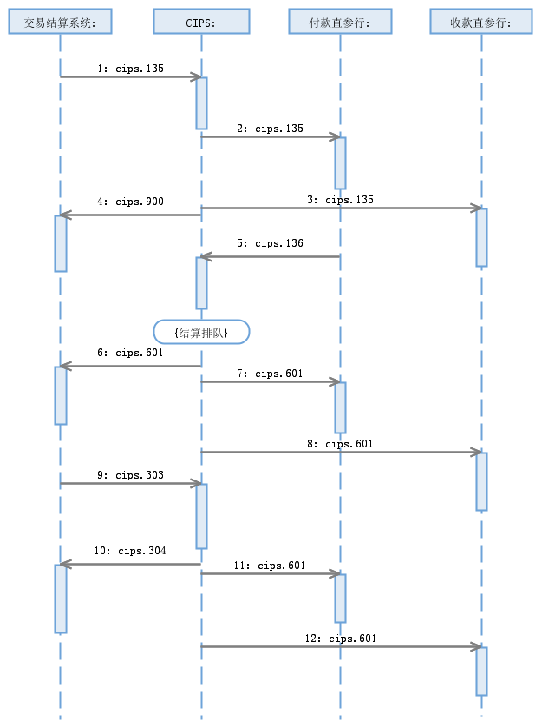
Trade Settlement System:
Debtor Direct Participant Bank:
Creditor Direct Participant Bank:
{Pending for settlement}

If CIPS has not yet received an AnswerForSSSByFMI message from Debtor Direct Participant Bank at the CLSG or NTCS phase, CIPS executes end-of-day return and sends a SettlementConfirmation message indicating “EDRN” to Trade Settlement System, Debtor Direct Participant Bank and Creditor Direct Participant Bank.
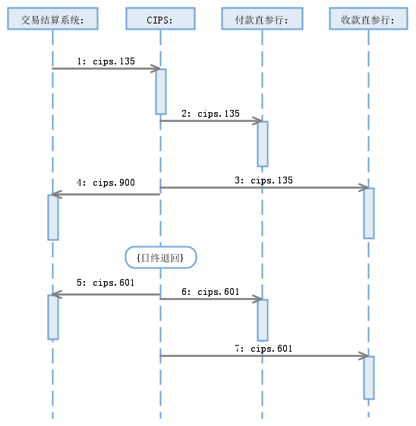
Trade Settlement System:
Debtor Direct Participant Bank:
Creditor Direct Participant Bank:
{End-of-day returned}

After pending for settlement of the business initiated by Trade Settlement System, if the business has not yet been settled or cancelled at the CLSG or NTCS phase, CIPS executes end-of-day return and sends a SettlementConfirmation message indicating “EDRN” to Trade Settlement System, Debtor Direct Participant Bank and Creditor Direct Participant Bank.
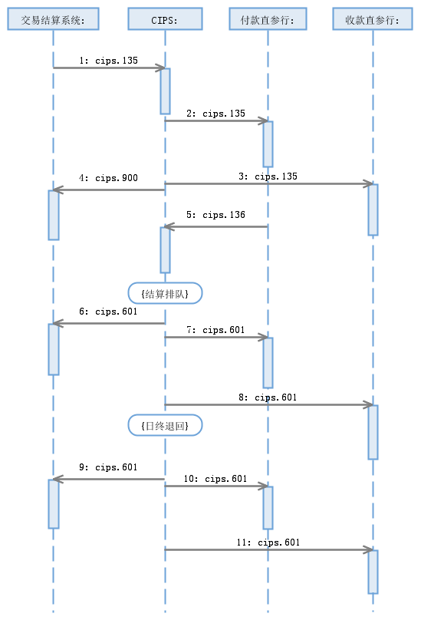
{Pending for settlement}
Trade Settlement System:
Debtor Direct Participant Bank:
Creditor Direct Participant Bank:
{End-of-day returned}

- Example
  - SecuritiesSettlementSystemByBank <cips.133.001.01>
Message Instance:
<?xml version="1.0" encoding="UTF-8"?>
<Document xmlns="urn:iso:std:iso:20022:tech:xsd:sese.023.001.06" xmlns:xsi="http://www.w3.org/2001/XMLSchema-instance">
<SctiesSttlmTxInstr>
<TxId>2017121106098508</TxId>
<SttlmTpAndAddtlParams>
<SctiesMvmntTp>DELI</SctiesMvmntTp>
<Pmt>APMT</Pmt>
</SttlmTpAndAddtlParams>
<TradDtls>
<TradId>1231232131</TradId>
<SttlmDt>
<Dt>
<DtTm>1900-01-01T00:00:00</DtTm>
</Dt>
</SttlmDt>
</TradDtls>
<FinInstrmId>
<OthrId>
<Id>000681</Id>
<Tp>
<Prtry>0</Prtry>
</Tp>
</OthrId>
</FinInstrmId>
<FinInstrmAttrbts>
<MtrtyDt>2017-12-18</MtrtyDt>
<FrstPmtDt>2017-12-11</FrstPmtDt>
</FinInstrmAttrbts>
<QtyAndAcctDtls>
<SttlmQty>
<Qty>
<FaceAmt>1000.00</FaceAmt>
</Qty>
</SttlmQty>
<SfkpgAcct>
<Id>0</Id>
</SfkpgAcct>
</QtyAndAcctDtls>
<SttlmParams>
<Prty>
<Prtry>
<Id>URGT</Id>
<Issr>0</Issr>
</Prtry>
</Prty>
<SctiesTxTp>
<Prtry>
<Id>SBTB</Id>
<Issr>0</Issr>
</Prtry>
</SctiesTxTp>
</SttlmParams>
<DlvrgSttlmPties>
<Dpstry>
<Id>
<AnyBIC>BKCHCNBJXXX</AnyBIC>
</Id>
</Dpstry>
<Pty1>
<Id>
<PrtryId>
<Id>BKCHAEADXXX</Id>
<Issr>0</Issr>
</PrtryId>
</Id>
</Pty1>
</DlvrgSttlmPties>
<RcvgSttlmPties>
<Dpstry>
<Id>
<AnyBIC>ABOCCNBJXXX</AnyBIC>
</Id>
</Dpstry>
<Pty1>
<Id>
<PrtryId>
<Id>ABOCSGSGXXX</Id>
<Issr>0</Issr>
</PrtryId>
</Id>
</Pty1>
</RcvgSttlmPties>
<CshPties>
<Dbtr>
<Id>
<NmAndAdr>
<Nm>Agricultural Bank of China Limited</Nm>
<Adr>
<AdrLine>Jiahao International Center</AdrLine>
<Ctry>CN</Ctry>
</Adr>
</NmAndAdr>
</Id>
<CshAcct>
<Prtry>ABOCCNBJXXX</Prtry>
</CshAcct>
<AddtlInf>
<DclrtnDtls>ABOCCNBJXXX</DclrtnDtls>
<PtyCtctDtls>First FMI</PtyCtctDtls>
</AddtlInf>
</Dbtr>
<DbtrAgt>
<Id>
<PrtryId>
<Id>ABOCCNBJXXX</Id>
<Issr>0</Issr>
</PrtryId>
</Id>
<AddtlInf>
<PtyCtctDtls>Agricultural Bank of China Limited</PtyCtctDtls>
</AddtlInf>
</DbtrAgt>
<Cdtr>
<Id>
<NmAndAdr>
<Nm>Bank of China Limited</Nm>
<Adr>
<AdrLine>Jiahao International Center</AdrLine>
<Ctry>CN</Ctry>
</Adr>
</NmAndAdr>
</Id>
<CshAcct>
<Prtry>BKCHCNBJXXX</Prtry>
</CshAcct>
<AddtlInf>
<DclrtnDtls>BKCHCNBJXXX</DclrtnDtls>
<PtyCtctDtls>Second FMI</PtyCtctDtls>
</AddtlInf>
</Cdtr>
<CdtrAgt>
<Id>
<PrtryId>
<Id>BKCHCNBJXXX</Id>
<Issr>0</Issr>
</PrtryId>
</Id>
<AddtlInf>
<PtyCtctDtls>Bank of China Limited</PtyCtctDtls>
</AddtlInf>
</CdtrAgt>
</CshPties>
<OthrAmts>
<AcrdIntrstAmt>
<Amt Ccy="CNY">12.00</Amt>
</AcrdIntrstAmt>
<TradAmt>
<Amt Ccy="CNY">24.00</Amt>
</TradAmt>
<AcrdCptlstnAmt>
<Amt Ccy="CNY">48.00</Amt>
</AcrdCptlstnAmt>
</OthrAmts>
<SplmtryData>
<PlcAndNm>/Document/SctiesSttlmTxInstr/TradDtls</PlcAndNm>
<Envlp>
<Cnts>
<InstgPty>CMBCCNBSXXX</InstgPty>
<OrgnlTradId>2017121100008888</OrgnlTradId>
<XpctdSttlmDt>2017-12-11</XpctdSttlmDt>
<RpSttlmAmt Ccy="CNY">36.00</RpSttlmAmt>
<RpIntrst Ccy="CNY">16.00</RpIntrst>
<Ustrd>pay me money</Ustrd>
</Cnts>
</Envlp>
</SplmtryData>
</SctiesSttlmTxInstr>
</Document>

