

CIPS Message Definition Report
Part 1: Clearing and Settlement—Clearing Institution Fund Settlement

V1.0.0
January 2021

Important Note: This Article is made out in both English and Chinese versions. We hereby set Chinese version as standard and English version as a reference should any conflicts occurred. If you have any questions, please contact us at bzb@cips.com.cn.

Revision Record
Version Number | Date | Revision Note | Scope
V1.0.0 | 26-10-2019 | [C]  CIPS Message Definition Report — Part 1: Clearing Institution Fund Settlement | All
Note: Change statuses are C — created, A — added, M — modified, and D — deleted.
Table of Contents

1 Introduction 1
1.1 Terms and Definitions 1
1.2 Abbreviations and Acronyms 1
1.3 Document Scope and Objectives 1
1.4 References 2
2 Scope and Functionality 2
2.1 Background 2
2.2 Scope 2
2.3 Groups of MessageDefinitions and Functionality 3
3 BusinessRoles and Participants 3
3.1 Clearing Institution Fund Settlement Business 3
4 BusinessProcess Description 3
4.1 Clearing Institution Fund Settlement Process Description 3
4.1.1 Direct Debit Process 4
4.1.2 Debit Confirmation Process 5
5 Description of BusinessActivities 5
5.1 Clearing Institution Fund Settlement 6
5.1.1 Direct Debit 6
5.1.2 Debit Confirmation 8
6 BusinessProcesses 10
6.1 Clearing Institution Fund Settlement 11
6.1.1 Direct Debit 11
6.1.2 Debit Confirmation 18
7 Example 26
7.1 NoticeOfMultiDebitCreditTransferByClearingInstitution <cips.153.001.01> 26

Introduction

Terms and Definitions
The terms involved in this document are defined as follows:
Term | Definition
BusinessRole | A BusinessRole represents an entity (or a class of entities) of an actual business.
Participant | A functional role played by a BusinessRole in a particular BusinessProcess or BusinessTransaction.
BusinessProcess | Business activities undefined but undertaken within a BusinessArea whereby each BusinessProcess fulfills one type of business activities and whereby a BusinessProcess may include and extend other BusinessProcesses.
BusinessTransaction | A particular solution that meets the communication requirements and the interaction requirements of a particular BusinessProcess and BusinessArea.
MessageDefinition | Formal description of the structure of a message instance.

The CIPS terms involved in this document are defined as follows:
Term | Description
Cross-border Interbank Payment System (CIPS) | CIPS provides fund clearing and settlement service for its Participants’ cross-border RMB payment transactions, financial market transactions, etc.
CIPS Direct Participant | CIPS Direct Participant refers to a domestic or an overseas institution that has a CIPS code and handles cross-border RMB payment and settlement businesses directly through CIPS. The operating agency of CIPS will open a CIPS account for each Direct Participant bank, and will also open a CIPS account for each Direct Participant FMI as required by prudent management.
CIPS Indirect Participant | CIPS Indirect Participant refers to a domestic or an overseas institution that has not opened a CIPS account but has a CIPS’ bank code and entrusts an appropriate CIPS Direct Participant to handle cross-border RMB payment and settlement businesses through CIPS.
Payment Business | Payment Business refers to credit transactions initiated or received by Participants through CIPS for fund settlement, including customer credit transfers, financial institution transfers and financial market transactions.
Clearing Institution Credit and Debit Transfer | Clearing Institution Credit and Debit Transfers refers to the fund transfer involved in the payment transactions between any two members of Clearing Institution and submitted by Clearing Institution to CIPS through a message for settlement, upon receiving which CIPS decides whether the debtor needs to confirm the payment according to the instructions in the message and complete the fund settlement of receivables and payables of Clearing Institution.

Abbreviations and Acronyms
Abbreviation/Acronyms | Definition
CIPS | Cross-border Interbank Payment System

Document Scope and Objectives
This document is the first part of the Remittance Message Definition Report (MDR) and describes the BusinessTransactions and underlying message set. For the sake of completeness, the document may also describe the BusinessActivities that are not in the scope of the BusinessProcesses covered in this document.
This document describes the following:
- the BusinessProcesses scope
- the BusinessRoles involved in these BusinessProcesses
The main objectives of this document are as follows:
- to explain the BusinessProcesses and BusinessActivities these messages have addressed
- to explain the BusinessProcesses and BusinessActivities these messages have addressed
- to give a high-level description of the BusinessProcesses and associated BusinessRoles
- to explain the BusinessProcesses and related Participants
- to present a list of MessageDefinitions

References
Document | Version | Date | Author
Message Exchange Standard for CNAPS2 | V1.4.7 | 05-2017 | China National Clearing Center, the People’s Bank of China
CIPS (Phase II) Requirements Specification | V1.0.0 | 05-2017 | China National Clearing Center, the People’s Bank of China
CIPS Message Exchange Standard V2.1.0 | V2.1.0 | 11-01-2019 | Payment System Development Center, China National Clearing Center, the People’s Bank of China
Requirements Specification for Multi-debit/credit Transfer by Clearing Institution | V0.5.0 | 01-2019 | China National Clearing Center, the People’s Bank of China

Scope and Functionality

Background
This Message Definition Report covers a set of 8 messages developed by CIPS for clearing institution fund settlement.

Scope
This message set covers the BusinessProcesses of clearing institution fund settlement. The following 8 messages are used to describe the BusinessProcesses:
- MultiDebitCreditTransferByClearingInstitution (cips.151.001.01): This message can be sent by Clearing Institution to CIPS for direct debit/debit confirmation of receivables and payables of Clearing Institution.
- NoticeOfMultiDebitCreditTransferByClearingInstitution (cips.153.001.01): Upon receiving a MultiDebitCreditTransferByClearingInstitution message, CIPS carries out fund settlement and other processing, and then sends this message to Clearing Institution and Debtor Direct Participant Bank.
- ReceiptOfMultiDebitCreditTransferByClearingInstitution (cips.154.001.01): CIPS accepts a MultiDebitCreditTransferByClearingInstitution message (debit confirmation); upon receiving a NoticeOfMultiDebitCreditTransferByClearingInstitution message (cips.153) from CIPS, Debtor Direct Participant Bank (receivables) replies with this message to inform CIPS of consent or rejection.
- PaymentCancellation (cips.303.001.01): For the payment initiated to CIPS, the Initiating Participant can send this message to CIPS.
- AnswerForPaymentCancellation (cips.304.001.01): CIPS replies cips.304 to Initiator for payment cancellation.
- SettlementConfirmation (cips.601.001.02): After the BusinessProcessStatus has changed (RJCT, ACSC, PDNG, EDRN), CIPS sends cips.601 to notify the Participants related to the settlement.
- CommonConfirmation (cips.900.001.01): Upon receiving a message from a Participant, CIPS replies with the processing result in cips.900, or vice versa.
- MessageAbandonNotice (cips.912.001.01): CIPS sends a cips.912 to abandon received message if CIPS can neither carry out any business processing nor reply with a business-level CommonConfirmation message.

Groups of MessageDefinitions and Functionality
MessageDefinition | ISO 20022 Identifier | CIPS Identifier
MultiDebitCreditTransferByClearingInstitution | pacs.009.001.06 | cips.151.001.01
NoticeOfMultiDebitCreditTransferByClearingInstitution | camt.054.001.07 | cips.153.001.01
ReceiptOfMultiDebitCreditTransferByClearingInstitution | pacs.002.001.09 | cips.154.001.01
PaymentCancellation | camt.008.001.05 | cips.303.001.02
AnswerForPaymentCancellation | pacs.002.001.05 | cips.304.001.02
SettlementConfirmation | pacs.002.001.05 | cips.601.001.02
CommonConfirmation | camt.025.001.03 | cips.900.001.01
MessageAbandonNotice | / | cips.912.001.01

BusinessRoles and Participants
A BusinessRole represents an entity (or a class of entities) of the real world, physical or legal, including a person or corporation. Examples of BusinessRoles: “Financial Institution”, and so on.
A Participant is a functional role played by a BusinessRole in a particular BusinessProcess or BusinessTransaction. Examples of Participants: the “user” of a system, “debtor”, “investor”, and so on.
The relationship between BusinessRoles and Participants is many-to-many. A BusinessRole can act as different Participants at different moments or at the same time. For example, a BusinessRole can be the “user” of a system, a “debtor” and an “investor” at the same time. In addition, different BusinessRoles can be involved as the same Participant.

Clearing Institution Fund Settlement Business
The BusinessRoles and Participants in clearing institution fund settlement are described below.
Participant and BusinessRole Definitions
Participant | Definition
CIPS | Cross-border Interbank Payment System
Direct Participant | A domestic/overseas banking or other financial institution that directly accepts the fund settlement services provided by CIPS.
Clearing Institution | An institution responsible for clearing management and execution.
BusinessRole | Definition
CIPS Participant | A participant that directly interacts with CIPS
Clearing System | Cross-border Interbank Payment System

Participant and BusinessRole Matrix
BusinessRole  Participant | CIPS Participant | Clearing System
CIPS |  | √
Direct Participant | √
Clearing Institution | √

BusinessProcess Description
This section describes the BusinessProcesses. Description of the BusinessProcesses and the information in the BusinessProcesses can help to identify relationships between the BusinessRoles.

Clearing Institution Fund Settlement Process Description
Basic Process:
- After netted clearing of a customer’s transfer, Clearing Institution sends a MultiDebitCreditTransferByClearingInstitution message to CIPS.
- Upon receiving the MultiDebitCreditTransferByClearingInstitution message, CIPS resolves the message. CIPS performs message format check and double accounting check. If the message fails to pass the two checks, CIPS goes to Step 2a) in the section of special process. CIPS also performs business legality check and digital signature validity check. If the message fails to pass the two checks, CIPS goes to Step 2b) in the section of special process. However, if the message passes all the checks, CIPS goes to 3).
- CIPS includes the MultiDebitCreditTransferByClearingInstitution message into Detailed Register of Debit/Credit Transfer by Clearing Institution and sets all detailed statuses as “ACSP”.
- In case of direct debit, CIPS goes to Step 5); in case of debit confirmation, CIPS goes to Step 6);
- CIPS settles the debit transactions in this message in the order from small to large according to detailed text IDs. If the settlement status is “ACSC”, CIPS modifies Detailed Register of Multi-debit/credit Transfer by Clearing Institution, sets the status as “ACSC”, and sends a NoticeOfMultiDebitCreditTransferByClearingInstitution message indicating “ACSC” to Debited Bank and Clearing Institution. If the settlement status is “PDNG”, CIPS modifies Detailed Register of Multi-debit/credit Transfer by Clearing Institution, sets the status as “PDNG”, and send a NoticeOfMultiDebitCreditTransferByClearingInstitution message indicating “PDNG” to Debited Bank and Clearing Institution. Then CIPS goes to Step 7).
- CIPS processes the debit transactions in the order from small to large according to detailed message ids, and sends NoticeOfMultiDebitCreditTransferByClearingInstitution containing the specified details and corresponding sign-off strings and indicating that the processing status is “FRWD” to Debited Direct Participant and Clearing Institution.
- CIPS settles the credit transactions in this message in the order from small to large according to detailed text ids. If the settlement status is “ACSC”, CIPS modifies Detailed Register of Multi-debit/credit Transfer by Clearing Institution, sets the status as “ACSC”, and sends a NoticeOfMultiDebitCreditTransferByClearingInstitution indicating “ACSC” to Credited Bank and Clearing Institution. If the settlement status is “PDNG”, CIPS modifies Detailed Register of Multi-debit/credit Transfer by Clearing Institution, sets the status as “PDNG”, and sends a NoticeOfMultiDebitCreditTransferByClearingInstitution message indicating “PDNG” to Clearing Institution.
special process:
2a) CIPS records error log and message log, rejects to process the transactions, abandons the message, and sends a “MessageAbandonNotice” message to Clearing Institution, indicating that the message is unable to be identified.
2b) CIPS records error log and message log, rejects the message, fills out Detailed Register of Multi-debit/credit Transfer by Clearing Institution, sets the status as “RJCT” in the detailed register, replies to Clearing Institution with a “CommonConfirmation” message, and informs Clearing Institution of the error causes.

Direct Debit Process
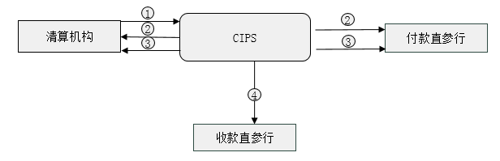
Clearing Institution
Debtor Direct Participant Bank
Creditor Direct Participant Bank
① Clearing Institution sends a MultiDebitCreditTransferByClearingInstitution message to CIPS.
② After review, CIPS sends a NoticeOfMultiDebitCreditTransferByClearingInstitution message to Clearing Institution and Debtor Direct Participant Bank.
③ After settlement, CIPS sends a SettlementConfirmation message to Debtor Direct Participant Bank and Clearing Institution.
④ After settlement, CIPS sends a NoticeOfMultiDebitCreditTransferByClearingInstitution message to Creditor Direct Participant Bank.

Debit Confirmation Process
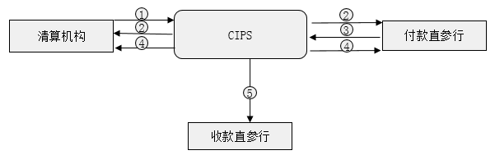
Clearing Institution
Debtor Direct Participant Bank
Creditor Direct Participant Bank
① Clearing Institution sends a MultiDebitCreditTransferByClearingInstitution message to CIPS.
② After review, CIPS sends a NoticeOfMultiDebitCreditTransferByClearingInstitution message to Clearing Institution and Debtor Direct Participant Bank.
③ Debtor Direct Participant Bank sends a ReceiptOfMultiDebitCreditTransferByClearingInstitution message to inform CIPS to conduct settlement operations.
④ After settlement, CIPS sends a NoticeOfMultiDebitCreditTransferByClearingInstitution message to Debtor Direct Participant Bank and Clearing Institution.
⑤ After settlement, CIPS sends a SettlementConfirmation message to Creditor Direct Participant Bank.

Description of BusinessActivities
This section presents the different BusinessActivities within each BusinessProcess. The BusinessActivities of a process are described with an activity diagram. The following is an introduction to the activity diagram.
describes the general lifecycle of a business process;
Start Point  shows where the lifecycle of the business process commences, and End Point  shows where the lifecycle of the business process may end;
Lozenge (or Diamond) indicates that a choice between several actions can be made;

There are activity streamlines between the Participants;
Information in the BusinessActivities is transmitted from a Participant to another.

Clearing Institution Fund Settlement

Direct Debit

Description of Normal Direct Debit Activities
No
Send a ClearingInstitutionDebit CreditTransfer message
Clearing Institution
Yes
No
Yes
Yes
No
No
Yes
Debtor Direct Participant Bank
Creditor Direct Participant Bank
Receive the MessageAbandonNotice message
Receive the CommonConfirmation message
Receive the ClearingInstitutionDebit CreditTransfer message

Message review
Pass message format check and double accounting check or not
Send a MessageAbandonNotice message
Pass business legality check and digital signature validity check or not
Send a CommonConfirmation message

Check whether there is a pending flag

Pending for settlement
Send a NoticeOfClearingInstitutionDebit CreditTransfer message

Pending settlement situation
Receive the NoticeOfClearing InstitutionDebitCredit Transfer message

Settlement succeeds at the end of the day or not

End-of-day returned

Settled
Send a SettlementConfirmation message
Send a NoticeOfClearing InstitutionDebitCredit Transfer message
Receive the SettlementConfirmation message
Receive the NoticeOfMultiDebitCreditTransferByClearingInstitution message
Receive the NoticeOfClearing InstitutionDebitCredit Transfer message
Receive the SettlementConfirmation message
N

Description of Special Direct Debit Activities
No
Send a ClearingInstitutionDebit CreditTransfer message
Clearing Institution
Yes
Receive the MessageAbandonNotice message
Receive the CommonConfirmation message
Receive the NoticeOfClearing InstitutionDebitCredit Transfer message
Send a PaymentCancellation message
Receive the AnswerForBusinessCancellation message
Receive the SettlementConfirmation message
Send a SettlementConfirmation message
Send a AnswerForBusinessCancellation message
Receive the PaymentCancellation message
Send a NoticeOfClearing InstitutionDebitCredit Transfer message
Pending for settlement
Send a CommonConfirmation message
Send a MessageAbandonNotice message
No
Yes
Pass message format check and double accounting check or not

Message review
Receive the ClearingInstitutionDebit CreditTransfer message
Pass business legality check and digital signature validity check or not
Receive the NoticeOfClearing InstitutionDebitCredit Transfer message
Receive the SettlementConfirmation message
Debtor Direct Participant Bank
Creditor Direct Participant Bank

Debit Confirmation

Description of Normal Debit Confirmation Activities
No
Send a MultiDebitCreditTransferByClearingInstitution message
Clearing Institution
Yes
Receive the MultiDebitCreditTransferByClearingInstitution message

Message review
Pass message format check and double accounting check or not
Send a MessageAbandonNotice message
No
Yes
Receive the MessageAbandonNotice message
Receive the CommonConfirmation message
Receive the NoticeOfClearing InstitutionDebitCredit Transfer message
Receive the NoticeOfClearing InstitutionDebitCredit Transfer message
Send a NoticeOfClearing InstitutionDebitCredit Transfer message
Pending for settlement
Settled
Send a SettlementConfirmation message
Settlement succeeds at the end of the day or not

End-of-day returned

Settled
Send a SettlementConfirmation message
Receive the SettlementConfirmation message
Send a NoticeOfMultiDebitCreditTransferByClearingInstitution message
Receive the SettlementConfirmation message
Receive the NoticeOfMultiDebitCreditTransferByClearingInstitution message
Receive the SettlementConfirmation message
Receive the NoticeOfClearing InstitutionDebitCredit Transfer message
Check whether there is a pending flag
Receive the ReceiptOfClearing InstitutionDebitCredit Transfer message
Send a NoticeOfClearing InstitutionDebitCredit Transfer message
Send a CommonConfirmation message
Receive the NoticeOfClearing InstitutionDebitCredit Transfer message
Receive the ReceiptOfClearing
InstitutionDebitCredit
Transfer message
Pass business legality check and digital signature validity check or not
Yes
Yes
No
No
Debtor Direct Participant Bank
Creditor Direct Participant Bank

Description of Special Debit Confirmation Activities
No
Send a ClearingInstitutionDebit CreditTransfer message
Clearing Institution
Yes
Debtor Direct Participant Bank
Creditor Direct Participant Bank
Receive the MessageAbandonNotice message
Receive the CommonConfirmation message
Receive the NoticeOfMultiDebitCreditTransferByClearingInstitution message
Receive the NoticeOfMultiDebitCreditTransferByClearingInstitution message
Send a PaymentCancellation message
Receive the AnswerForBusinessCancellation message
Receive the SettlementConfirmation message
Send a SettlementConfirmation message
Send a AnswerForBusinessCancellation message
Receive the PaymentCancellation message
Receive the NoticeOfMultiDebitCreditTransferByClearingInstitution message

Pending for settlement
Receive the ReceiptOfClearingInstitution DebitCreditTransfer message
Send a NoticeOfMultiDebitCreditTransferByClearingInstitution message
Send a CommonConfirmation message
Pass business legality check and digital signature validity check or not
Send a MessageAbandonNotice message
Pass message format check and double accounting check or not
Message review
Receive the ClearingInstitutionDebit CreditTransfer message
Yes
No
Receive the NoticeOfClearing InstitutionDebitCredit Transfer message
Receive the ReceiptOfClearing InstitutionDebitCreditTransfer message
Receive the NoticeOfClearing InstitutionDebitCredit Transfer message
Receive the SettlementConfirmation message

BusinessProcesses
This section describes the message flows based on the following activity diagrams so as to show the specific communication processes in the BusinessProcesses or BusinessTransactions.

Clearing Institution Fund Settlement
CIPS accepts a MultiDebitCreditTransferByClearingInstitution message (direct debit), which may contain the details of one or more receivable(s)/payable(s). After fund settlement, CIPS returns the business processing results to Clearing Institution, Debtor Direct Participant Bank (receivables) and Creditor Direct Participant Bank (payables) through a NoticeOfMultiDebitCreditTransferByClearingInstitution message.
CIPS accepts a MultiDebitCreditTransferByClearingInstitution message (debit confirmation), which may contain the details of one or more receivable(s)/payable(s). Upon receiving the message, CIPS sends a NoticeOfMultiDebitCreditTransferByClearingInstitution message indicating “FRWD” to Clearing Institution and Debtor Direct Participant Bank (receivables), then carries out fund settlement of payables; after fund settlement, CIPS replies to Clearing Institution and Creditor Direct Participant Bank (payables) with a NoticeOfMultiDebitCreditTransferByClearingInstitution message.
Upon receiving a ReceiptOfMultiDebitCreditTransferByClearingInstitution message from Debtor Direct Participant Bank, CIPS carries out fund settlement of receivables; after fund settlement, CIPS replies to Clearing Institution and Debtor Direct Participant Bank (receivables) with a SettlementConfirmation message.

Direct Debit
CIPS accepts a MultiDebitCreditTransferByClearingInstitution message (direct debit), which may contain the details of one or more receivable(s)/payable(s). After fund settlement, CIPS returns the business processing results to Clearing Institution, Debtor Direct Participant Bank (receivables) and Creditor Direct Participant Bank (payables) through NoticeOfMultiDebitCreditTransferByClearingInstitution.

Normal Process of Direct Debit
The business initiated by a Participant is settled smoothly.
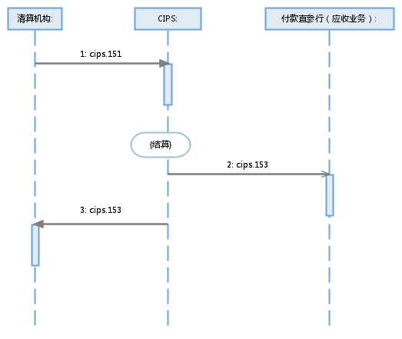
Clearing Institution
{Settled}
Debtor Direct Participant Bank (receivables)

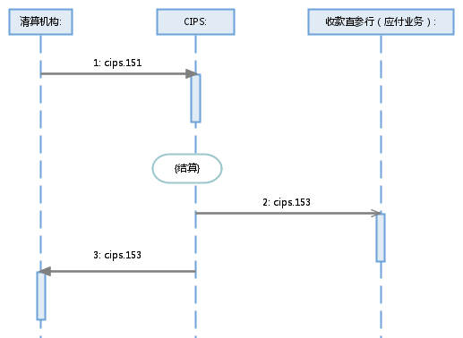
Clearing Institution

{Settled}
Creditor Direct Participant Bank (payables)

In case of pending for settlement of the business initiated by a Participant, a NoticeOfMultiDebitCreditTransferByClearingInstitution message indicating “PDNG” is sent to Clearing Institution and Debtor Direct Participant Bank; after settlement, a SettlementConfirmation message indicating “ACSC” is sent to Clearing Institution and Debtor Direct Participant Bank.

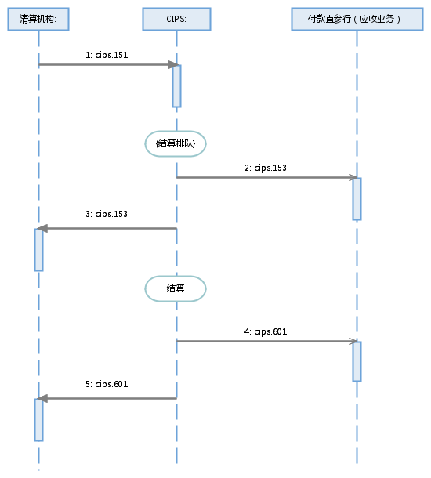
Clearing Institution

Settled
Debtor Direct Participant Bank (receivables)
{Pending for settlement}
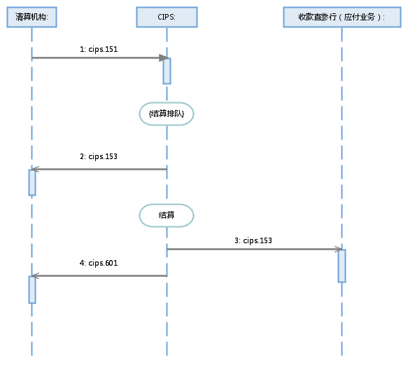
Clearing Institution
Settled
Creditor Direct Participant Bank (payables)
{Pending for settlement}
Clearing Institution
The business initiated by a Participant is rejected by CIPS in whole due to the error(s) found in business checks.
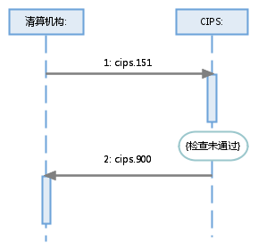
{Failure to pass the checks}

CIPS abandons a message sent by an Initiating Participant due to nonexistence of DirectParticipantIdentification, invalid DirectParticipantIdentification, wrong message format or double accounting.

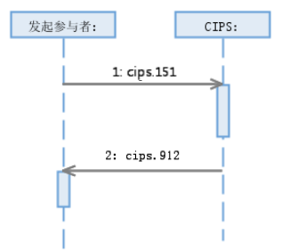
Initiating Participant:

Special Process of Direct Debit
- Clearing Institution cancels the business during pending period.
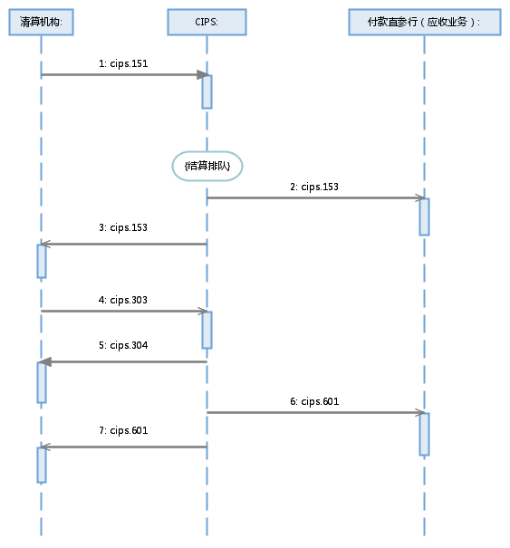
{Pending for settlement}
Debtor Direct Participant Bank (receivables)
Clearing Institution

- CIPS executes end-of-day return for the business initiated by a Participant but yet not settled at day end after pending for settlement.
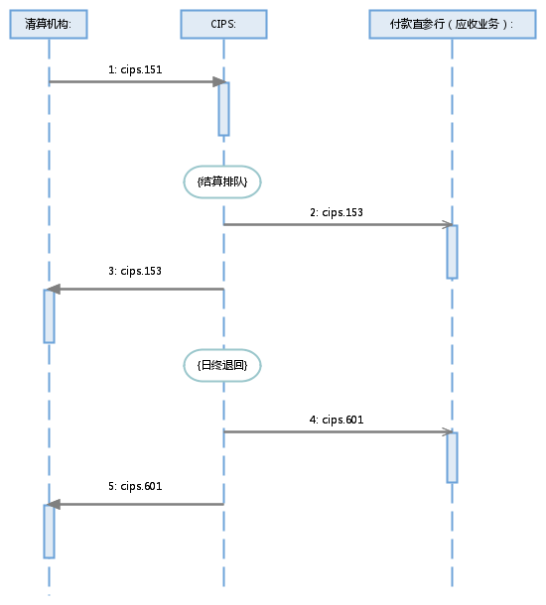
Clearing Institution
{Pending for settlement}
Debtor Direct Participant Bank (receivables)
{End-of-day returned}

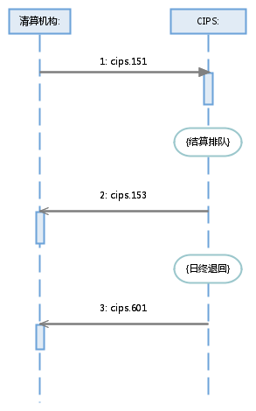
Clearing Institution
{Pending for settlement}
{End-of-day returned}

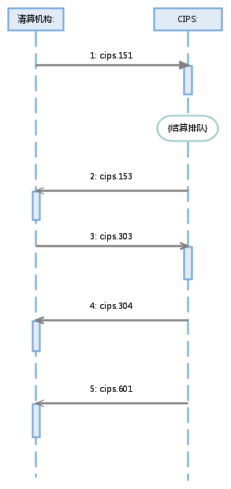
Clearing Institution
{Pending for settlement}

Debit Confirmation
CIPS accepts a MultiDebitCreditTransferByClearingInstitution message (debit confirmation), which may contain the details of one or more receivable(s)/payable(s). Upon receiving the message, CIPS sends a NoticeOfMultiDebitCreditTransferByClearingInstitution message indicating “FRWD” to Clearing Institution and Debtor Direct Participant Bank (receivables), then carries out fund settlement of payables; after fund settlement, CIPS replies to Clearing Institution and Creditor Direct Participant Bank (payables) with a NoticeOfMultiDebitCreditTransferByClearingInstitution message.
Upon receiving a ReceiptOfMultiDebitCreditTransferByClearingInstitution message from Debtor Direct Participant Bank, CIPS carries out fund settlement of receivables; after fund settlement, CIPS replies to Clearing Institution and Debtor Direct Participant Bank (receivables) with a SettlementConfirmation message.

Normal Process of Debit Confirmation
The business initiated by Participants is settled smoothly.
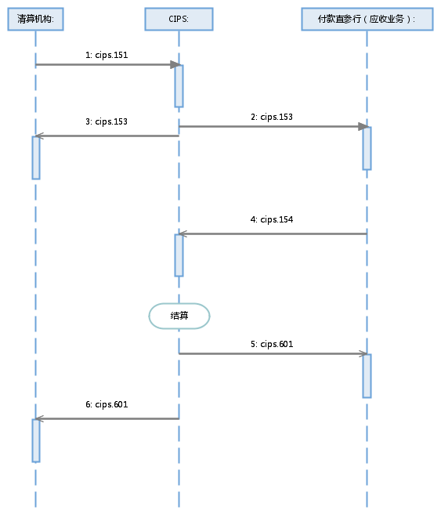
Clearing Institution
Settled
Debtor Direct Participant Bank (receivables)
Settled

Clearing Institution
Creditor Direct Participant Bank (payables)

In case of pending for settlement of the business initiated by a Participant, a SettlementConfirmation message indicating “PDNG” is sent to Clearing Institution and Debtor Direct Participant Bank; after settlement, the business processing results are returned to Clearing Institution and Debtor Direct Participant Bank through a SettlementConfirmation message.
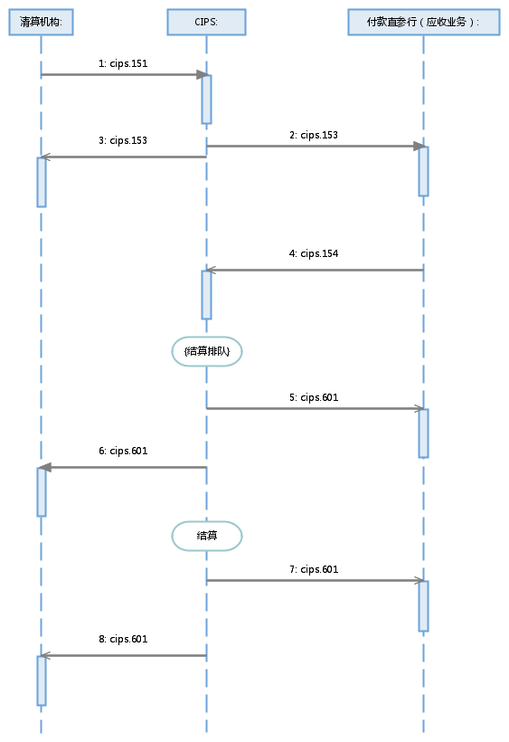
Clearing Institution
{Pending for settlement}
Debtor Direct Participant Bank (receivables)
Settled

Clearing Institution
{Pending for settlement}
Creditor Direct Participant Bank (payables)
Settled

(1) The business initiated by a Participant is rejected by CIPS as a whole packet due to the error(s) found in business checks.
Clearing Institution
{Failure to pass the checks}

(2) CIPS abandons a message sent by a Participant due to nonexistence of DirectParticipantIdentification, invalid DirectParticipantIdentification, wrong message format or double accounting.
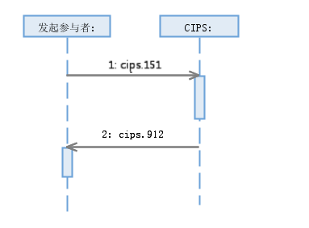
Initiating Participant:

Special Process Debit Confirmation
(1) Clearing Institution cancels the business during pending period.
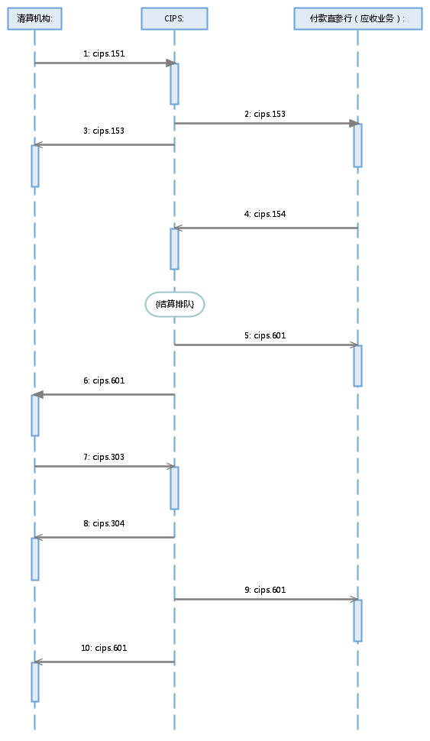
Clearing Institution
{Pending for settlement}
Debtor Direct Participant Bank (receivables)

Clearing Institution
{Pending for settlement}

(2) If the business initiated by a Participant has not yet been settled at day end after pending for settlement, CIPS executes end-of-day return.
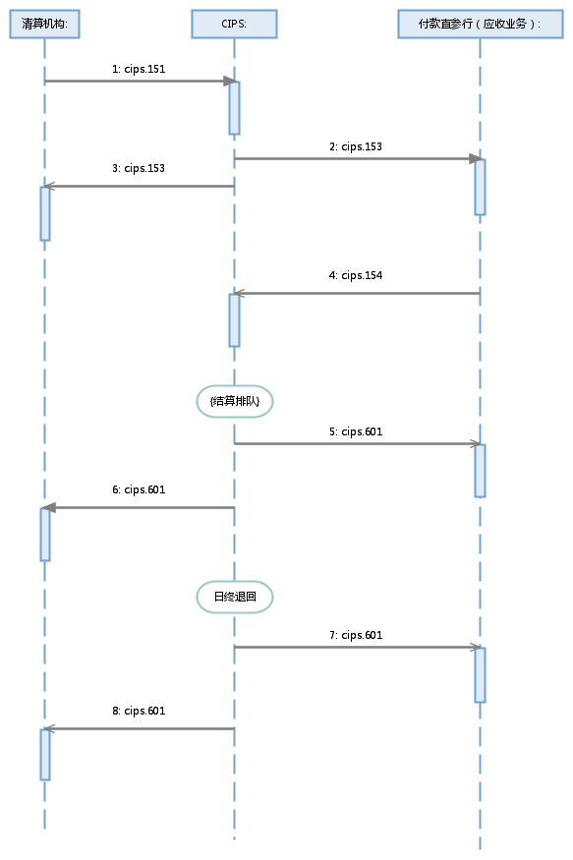
Clearing Institution
{End-of-day returned}
Debtor Direct Participant Bank (receivables)
{Pending for settlement}

Clearing Institution
{Pending for settlement}

{End-of-day returned}

Example

NoticeOfMultiDebitCreditTransferByClearingInstitution <cips.153.001.01>
Message Instance:
<GrpHdr>
<MsgId>2017121161312211</MsgId>
<CreDtTm>2014-12-17T09:30:47</CreDtTm>
<NbOfTxs>1</NbOfTxs>
<SttlmInf>
<SttlmMtd>CLRG</SttlmMtd>
</SttlmInf>
<PmtTpInf>
<SvcLvl>
<Prtry>RQUR</Prtry>
</SvcLvl>
</PmtTpInf>
<InstgAgt>
<FinInstnId>
<ClrSysMmbId>
<MmbId>CMBCCNBSXXX</MmbId>
</ClrSysMmbId>
</FinInstnId>
</InstgAgt>
</GrpHdr>
<CdtTrfTxInf>
<PmtId>
<InstrId>01234567</InstrId>
<EndToEndId>DB00005800000001</EndToEndId>
<TxId>2017121161312211</TxId>
</PmtId>
<PmtTpInf>
<CtgyPurp>
<Prtry>GODX</Prtry>
</CtgyPurp>
</PmtTpInf>
<IntrBkSttlmAmt Ccy="CNY">111222.14</IntrBkSttlmAmt>
<InstgAgt>
<FinInstnId>
<ClrSysMmbId>
<MmbId>BKCHCNBJXXX</MmbId>
</ClrSysMmbId>
</FinInstnId>
<BrnchId>
<Id>BKCHAEADXXX</Id>
</BrnchId>
</InstgAgt>
<InstdAgt>
<FinInstnId>
<ClrSysMmbId>
<MmbId>CMBCCNBSXXX</MmbId>
</ClrSysMmbId>
</FinInstnId>
<BrnchId>
<Id>CMBCHKHHXXX</Id>
</BrnchId>
</InstdAgt>
<IntrmyAgt1>
<FinInstnId>
<ClrSysMmbId>
<MmbId>CITICNSXBJG</MmbId>
</ClrSysMmbId>
<Nm>Citibank (China) Co., Ltd., Beijing Branch</Nm>
</FinInstnId>
</IntrmyAgt1>
<Dbtr>
<FinInstnId>
<Nm>UBS AG BEIJING BRANCH</Nm>
<PstlAdr>
<Ctry>CN</Ctry>
<AdrLine>No. 116, Inner Chaoyangmen Main Street, Chaoyang District, Beijing, China</AdrLine>
</PstlAdr>
</FinInstnId>
</Dbtr>
<DbtrAcct>
<Id>
<Othr>
<Id>6221222233334444</Id>
</Othr>
</Id>
</DbtrAcct>
<DbtrAgt>
<FinInstnId>
<ClrSysMmbId>
<MmbId>UBSWCNBJXXX</MmbId>
</ClrSysMmbId>
<Nm>UBS AG BEIJING BRANCH</Nm>
</FinInstnId>
</DbtrAgt>
<CdtrAgt>
<FinInstnId>
<ClrSysMmbId>
<MmbId>DBSSCNBJXXX</MmbId>
</ClrSysMmbId>
<Nm>DBS Bank (China) Ltd, Beijing Branch</Nm>
</FinInstnId>
</CdtrAgt>
<Cdtr>
<FinInstnId>
<Nm>DBS Bank (China) Ltd, Beijing Branch</Nm>
<PstlAdr>
<Ctry>CN</Ctry>
<AdrLine>No. 8, Shixing Avenue, Shijingshan District, Beijing, China</AdrLine>
</PstlAdr>
</FinInstnId>
</Cdtr>
<CdtrAcct>
<Id>
<Othr>
<Id>2222333344445555</Id>
</Othr>
</Id>
</CdtrAcct>
<RmtInf>
<Ustrd>RemittanceInformation</Ustrd>
</RmtInf>
<SplmtryData>
<PlcAndNm>/Document/FICdtTrf/CdtTrfTxInf</PlcAndNm>
<Envlp>
<Data>
<Data>MEUCIEuMj4uufTk0CSQKkixblZARYtulqZEGv5TExNENZcq7AiEA8WOzR8KFtMX209z9Fi9pUrpC9RVqFI8+eH1bMJc2vTU=</Data>
</Data>
</Envlp>
</SplmtryData>
</CdtTrfTxInf>
<SplmtryData>
<PlcAndNm>/Document/FICdtTrf</PlcAndNm>
<Envlp>
<Cnts>
<XpctdSttlmDt>2017-12-11</XpctdSttlmDt>
</Cnts>
</Envlp>
</SplmtryData>
</FICdtTrf>
</Document>

