

CIPS Message Definition Report
Part 1: Account Management

V1.0.0
January 2021

Important Note: This Article is made out in both English and Chinese versions. We hereby set Chinese version as standard and English version as a reference should any conflicts occurred. If you have any questions, please contact us at bzb@cips.com.cn.

Revision Record
Version Number | Date | Revision Note | Scope
V1.0.0 | 26-10-2019 | [C]  CIPS Message Definition Report — Part 1: Account Management | All
Note: Change statuses are C — created, A — added, M — modified, and D — deleted.
Table of Contents

1 Introduction 1
1.1 Terms and Definitions 1
1.2 Abbreviations and Acronyms 1
1.3 Document Scope and Objectives 2
1.4 References 2
2 Scope and Functionality 2
2.1 Background 2
2.2 Scope 2
2.3 Groups of MessageDefinitions and Functionality 3
3 BusinessRoles and Participants 3
3.1 Account Management Business 4
4 BusinessProcess Description 4
4.1 Account Control Process Description 4
4.1.1 Fund Adjustment Notification 4
4.1.2 Account Balance Prewarning Mechanism 5
4.1.3 Account Management Notification 5
4.2 Account Information Query Process Description 5
5 Description of BusinessActivities 5
5.1 Account Control 6
5.1.1 Fund Adjustment Notification 6
5.1.2 Request for Prewarning Value Setting 6
5.1.3 Balance PreWarning Notification 7
5.1.4 Account Management Notification 8
5.2 Account Information Query 8
6 BusinessProcesses 9
6.1 Account Control 9
6.1.1 Fund Adjustment Notification 9
6.1.2 Request for Prewarning Value Setting 10
6.1.3 Balance Prewarning Notification 11
6.1.4 Account Management Notification 11
6.2 Account Information Query 12
6.2.1 Normal Process of Account Information Query 12
6.2.2 Special Process of Account Information Query 12
7 Example 13
7.1 RequestForPrewarningValueSetting <cips.354.001.01> 13

- Introduction
  - Terms and Definitions
The terms involved in this document are defined as follows:
Term | Definition
BusinessRole | A BusinessRole represents an entity (or a class of entities) of an actual business.
Participant | A functional role played by a BusinessRole in a particular BusinessProcess or BusinessTransaction.
BusinessProcess | Business activities undefined but undertaken within a BusinessArea whereby each BusinessProcess fulfills one type of business activities and whereby a BusinessProcess may include and extend other BusinessProcesses.
BusinessTransaction | A particular solution that meets the communication requirements and the interaction requirements of a particular BusinessProcess and BusinessArea.
MessageDefinition | Formal description of the structure of a message instance.

The CIPS terms involved in this document are defined as follows:
Term | Description
Cross-border Interbank Payment System (CIPS) | CIPS provides fund clearing and settlement service for its Participants’ cross-border RMB payment transactions, financial market transactions, etc.
High Value Payment System  (HVPS) | High Value Payment System (HVPS) is an application system used by the People’s Bank of China (PBOC) to handle local or non-local inter-bank and intra-bank high value credit and emergency low value credit payment transactions, PBOC’s credit payment transactions and instant transfer transactions according to the needs of payment clearing. CIPS completes such operations as initial prefunding (reserved prefunding), fund increase (reserved prefund increase), fund reduction (withdrawal) and closing out through HVPS.
CIPS Direct Participant | CIPS Direct Participant refers to a domestic or an overseas institution that has a CIPS code and handles cross-border RMB payment and settlement businesses directly through CIPS. The operating agency of CIPS will open a CIPS account for each Direct Participant bank, and will also open a CIPS account for each Direct Participant FMI as required by prudent management.
DvP/PvP Settlement | CIPS supports DvP (Delivery Versus Payment) settlement and PvP (Payment Versus Payment) settlement. DvP/PvP settlement can be initiated by a bank or FMI as a direct participant.
Custodian Bank | Custodian Bank refers to a domestic direct participant bank that meets the requirements and has signed a fund custody agreement with a direct participant having no HVPS clearing account to provide related services such as initial prefunding (reserved prefunding) and fund increase (reserved prefund increase).
Entrusted Bank | Entrusted Bank refers to an overseas CIPS direct participant that has entered into a payment settlement service agreement with a Custodian Bank.

  - Abbreviations and Acronyms
Abbreviation/Acronyms | Definition
CIPS | Cross-border Interbank Payment System
HVPS | High Value Payment System

  - Document Scope and Objectives
This document is the first part of the Remittance Message Definition Report (MDR) and describes the BusinessTransactions and underlying message set. For the sake of completeness, the document may also describe the BusinessActivities that are not in the scope of the BusinessProcesses covered in this document.
This document describes the following:
- the BusinessProcesses scope
- the BusinessRoles involved in these BusinessProcesses
The main objectives of this document are as follows:
- to explain the BusinessProcesses and BusinessActivities these messages have addressed
- to explain the BusinessProcesses and BusinessActivities these messages have addressed
- to give a high-level description of the BusinessProcesses and associated BusinessRoles
- to explain the BusinessProcesses and related Participants
- to present a list of MessageDefinitions
  - References
Document | Version | Date | Author
Message Exchange Standard for CNAPS2 | V1.4.7 | 05-2017 | China National Clearing Center, the People’s Bank of China
CIPS (Phase II) Requirements Specification | V1.0.0 | 05-2017 | China National Clearing Center, the People’s Bank of China
CIPS Message Exchange Standard V2.1.0 | V2.1.0 | 11-01-2019 | Payment System Development Center, China National Clearing Center, the People’s Bank of China
Requirements Specification for Multi-debit/credit Transfer by Clearing Institution | V0.5.0 | 01-2019 | China National Clearing Center, the People’s Bank of China

- Scope and Functionality
  - Background
This Message Definition Report covers a set of 8 messages developed by CIPS for account management.
  - Scope
This message set covers the BusinessProcesses of account management. The following 8 messages are used to describe the BusinessProcesses:
- FundAdjustment (cips.352.001.02): Upon receiving a RequestForFundReduction or RequestForFrozenFundReduction message from a Participant, if reduction succeeds, CIPS sends this message to inform the Participant of the fund change.
- RequestForPrewarningValueSetting (cips.354.001.01): A Participant sends this message to CIPS for setting, adjusting or cancelling its account balance prewarning value.
- BalancePrewarningNotice (cips.355.001.01): CIPS sends this message to inform a Participant that the current balance is lower than the prewarning value.
- QueryofClearingAccount (cips.356.001.02): A Participant sends this message to CIPS for querying the information related to its clearing account.
- AnswerForQueryofClearingAccount (cips.357.001.02): CIPS sends this message to return the related clearing account information to the QueryofClearingAccount message sender.
- AccountManagement (cips.358.001.02): After CIPS operates a clearing account or a Participant succeeds in initial prefunding/reserved prefunding, CIPS sends this message to inform the Participantof the related information of the account.
- CommonConfirmation (cips.900.001.01): Upon receiving a message from a Participant, CIPS replies with the processing result in cips.900, or vice versa.
- MessageAbandonNotice (cips.912.001.01): CIPS sends a cips.912 to abandon received message if CIPS can neither carry out any business processing nor reply with a business-level CommonConfirmation message.
  - Groups of MessageDefinitions and Functionality
MessageDefinition | ISO 20022 Identifier | CIPS Identifier
FundAdjustment | / | cips.352.001.02
RequestForPrewarningValueSetting | camt.011.001.05 | cips.354.001.01
BalancePrewarningNotice | camt.010.001.05 | cips.355.001.01
QueryofClearingAccount | camt.003.001.05 | cips.356.001.02
AnswerForQueryofClearingAccount | camt.004.001.06 | cips.357.001.02
AccountManagement | camt.004.001.06 | cips.358.001.02
CommonConfirmation | camt.025.001.03 | cips.900.001.01
MessageAbandonNotice | / | cips.912.001.01

- BusinessRoles and Participants
A BusinessRole represents an entity (or a class of entities) of the real world, physical or legal, including a person or corporation. Examples of BusinessRoles: “Financial Institution”, and so on.
A Participant is a functional role played by a BusinessRole in a particular BusinessProcess or BusinessTransaction. Examples of Participants: the “user” of a system, “debtor”, “investor”, and so on.
The relationship between BusinessRoles and Participants is many-to-many. A BusinessRole can act as different Participants at different moments or at the same time. For example, a BusinessRole can be the “user” of a system, a “debtor” and an “investor” at the same time. In addition, different BusinessRoles can be involved as the same Participant.
  - Account Management Business
The BusinessRoles and Participants in account management business are described below.
Participant and BusinessRole Definitions
Participant | Definition
CIPS | Cross-border Interbank Payment System
Direct Participant | A domestic/overseas banking or other financial institution that directly accepts the fund settlement services provided by CIPS.
BusinessRole | Definition
CIPS Participant | A participant that directly interacts with CIPS
Clearing System | Cross-border Interbank Payment System

Participant and BusinessRole Matrix
BusinessRole  Participant | CIPS Participant | Clearing System
CIPS |  | √
Direct Participant | √

- BusinessProcess Description
This section describes the BusinessProcesses. Description of the BusinessProcesses and the information in the BusinessProcesses can help to identify relationships between the BusinessRoles.
  - Account Control Process Description
    - Fund Adjustment Notification
The specific process of fund adjustment notification is shown in the figure below:
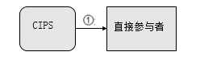
Direct Participant
① After a Participant has completed prefunding, closing out, fund reduction and withdrawal, CIPS sends this message to inform the Participant of the fund change.
    - Account Balance Prewarning Mechanism
The specific working process of account balance warning mechanism is shown in the figure below:
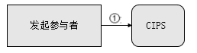
Participants
① Participants can set the available balance prewarning values for their fund accounts, and CIPS provides real-time monitoring of Direct Participants’ fund accounts. When the available balance of some fund accounts is lower than corresponding prewarning values, CIPS will open the balance monitoring window and simultaneously inform the related Participants of the fund shortage; after these Participants have replenished their accounts, the monitoring window will be closed automatically.
    - Account Management Notification
The specific process of account management notification is shown in the figure below:
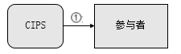
Participant
① After CIPS operates a clearing account or a Participant succeeds in initial prefunding/reserved prefunding, CIPS sends an AccountManagement message to inform the Participant of the related information of the account.
  - Account Information Query Process Description
The specific process of account information query is shown in the figure below:
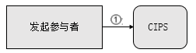
Participants
Participants can send a message to CIPS for querying their account balances, account statuses, initial prefunding statuses, etc.
- Description of BusinessActivities
This section presents the different BusinessActivities within each BusinessProcess. The BusinessActivities of a process are described with an activity diagram. The following is an introduction to the activity diagram.
- describes the general lifecycle of a business process;
- Start Point  shows where the lifecycle of the business process commences, and End Point  shows where the lifecycle of the business process may end;
- Lozenge (or Diamond) indicates that a choice between several actions can be made;
- There are activity streamlines between the Participants;
Information in the BusinessActivities is transmitted from a Participant to another.
  - Account Control
    - Fund Adjustment Notification
After a Participant has completed prefunding, closing out, fund reduction, reserved prefund increase and withdrawal, CIPS sends a FundAdjustment message to inform the Participant of the fund change.
If a Participant has an entrusted bank, CIPS will also send a FundAdjustment message to inform the Participant of the fund change after the bank completes prefunding, closing out, reserved prefund increase and withdrawal.

After a Participant has completed prefunding, the Participant can estimate its own prefunding status by comparing the balance adjusted in the FundAdjustment message with the minimum initial prefunding requirement. CIPS sends an AccountManagement message to inform the related Participant of the successful prefunding after entering the daytime session.
Send a FundAdjustment message to the Participants related to the business
Participant
Receive the FundAdjustment message

    - Request for Prewarning Value Setting
A Participant can set, adjust or cancel its account balance prewarning value through a RequestForPrewarningValueSetting message. A Participant sends a RequestForPrewarningValueSetting message to CIPS; upon receiving this message, CIPS operates the account accordingly, and sends a CommonConfirmation message to the Participant.
Participant
Send a RequestforPrewarningValueSetting message to CIPS
Receive the MessageAbandonNotice message
Receive the CommonConfirmation message
Receive the RequestforPrewarningValueSetting message
Message review
Pass message format check and double accounting check or not
Send a MessageAbandonNotice message
Send a CommonConfirmation message
Yes
No
    - Balance PreWarning Notification
When a Participant’s current balance is lower than the balance prewarning value, CIPS will open the Participant’s balance prewarning window and send a BalancePrewarningNotice message to the Participant.
Send a BalancePrewarningNotice message to the Participant whose balance prewarning window has been opened
Participant
Receive the BalancePrewarningNotice message

    - Account Management Notification
After operating a clearing account, CIPS sends an AccountManagement message to the related Participants.
CIPS sends an AccountManagement message to inform participants of their successful initial/reserved prefunding after entering the daytime/nighttime session.
In case that a Participant is a entrusted bank, CIPS will also send a related status change notice to the corresponding custodian bank.
Send an AccountManagement message to the Participants of the business
Participant
Receive the AccountManagement message
  - Account Information Query
Participants can query the information related to their clearing accounts with a QueryofClearingAccount message. CIPS returns the query results to the related Participants with an AnswerForQueryofClearingAccount message according to the specified conditions.
Participants
Send a QueryofClearingAccount message to CIPS
Receive the MessageAbandonNotice message
Receive the AnswerforQueryofClearing Account message
Receive the QueryofClearingAccount message
Message review
Pass message format check and double accounting check or not
Send a MessageAbandon Notice message
Send an AnswerforQueryofClearing Account message
Yes
No

- BusinessProcesses
This section describes the message flows based on the following activity diagrams so as to show the specific communication processes in the BusinessProcesses or BusinessTransactions.
  - Account Control
    - Fund Adjustment Notification
After a Participant has completed prefunding, closing out, fund reduction, reserved prefund increase and withdrawal, CIPS sends a FundAdjustment message to inform the Participant of the fund change.
If a Participant has a entrusted bank, CIPS will also send a FundAdjustment message to inform the Participant of the fund change after the bank completes prefunding, closing out, reserved prefund increase and withdrawal.
After a Participant has completed prefunding, the Participant can estimate its own prefunding status by comparing the balance adjusted in the FundAdjustment message with the minimum initial prefunding requirement. CIPS sends an AccountManagement message to inform the related Participant of the successful prefunding after entering the daytime session.
After a Participant has completed prefunding, closing out, fund reduction, reserved prefund increase and withdrawal, CIPS sends a FundAdjustment message to inform the Participant.
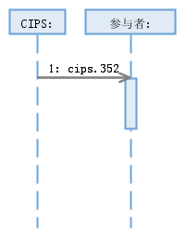
Participant:
    - Request for Prewarning Value Setting
A Participant can set, adjust or cancel its account balance prewarning value through a RequestForPrewarningValueSetting message. A Participant sends a RequestForPrewarningValueSetting message to CIPS; upon receiving this message, CIPS operates the account accordingly, and sends a CommonConfirmation message to the Participant.
      - Normal Process of Request for Balance Prewarning Value Setting
A Participant sends a RequestForPrewarningValueSetting message to CIPS. If CIPS fails to set a prewarning value or perform business checks, CIPS will reply with a CommonConfirmation message.
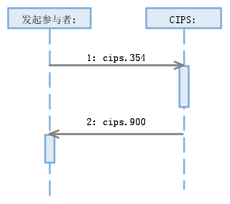
Participant:
      - Special Process of Request for Balance Prewarning Value Setting
CIPS abandons a RequestForPrewarningValueSetting message sent by a Participant due to nonexistence of DirectParticipantIdentification, invalid DirectParticipantIdentification, wrong message format or double accounting.
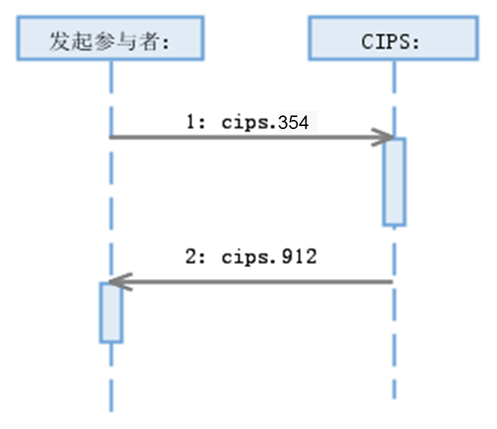
Participant:
    - Balance Prewarning Notification
When a Participant’s current balance is lower than the balance prewarning value, CIPS will open the Participant’s balance prewarning window and send a BalancePrewarningNotice message to the Participant.
If a Participant’s balance prewarning window is open and its current balance is higher than its balance prewarning value, CIPS will close the window and send a BalancePrewarningNotice message to the Participant.
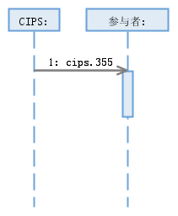
Participant:
    - Account Management Notification
After CIPS operates a clearing account, it sends an AccountManagement message to the related Participant.
CIPS sends an AccountManagement message to inform participants of their successful initial/reserved prefunding after entering the daytime/nighttime session.
In case that a Participant is an entrusted bank, CIPS will also send a related status change notice to the corresponding custodian bank.
After operating a clearing account, CIPS sends an AccountManagement message to the related Participants.
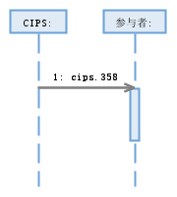
Participants:
  - Account Information Query
Participants can query the information related to their clearing accounts with this message. CIPS returns the query results to Initiating Direct Participants through an AnswerForQueryofClearingAccount message according to the specified conditions.
    - Normal Process of Account Information Query
A Direct Participant sends a QueryofClearingAccount message to CIPS; CIPS returns the query result to the Direct Participant with an AnswerForQueryofClearingAccount message; if the message received by CIPS fails the business checks, CIPS returns an AnswerForQueryofClearingAccount message to inform the Direct Participant of the failure.
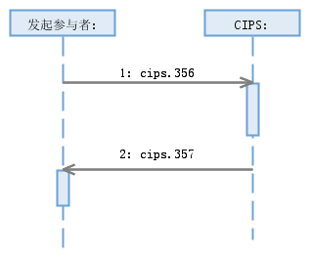
Participant:
    - Special Process of Account Information Query
CIPS abandons a QueryofClearingAccount message sent by a Participant due to nonexistence of DirectParticipantIdentification, invalid DirectParticipantIdentification, wrong message format or double accounting.
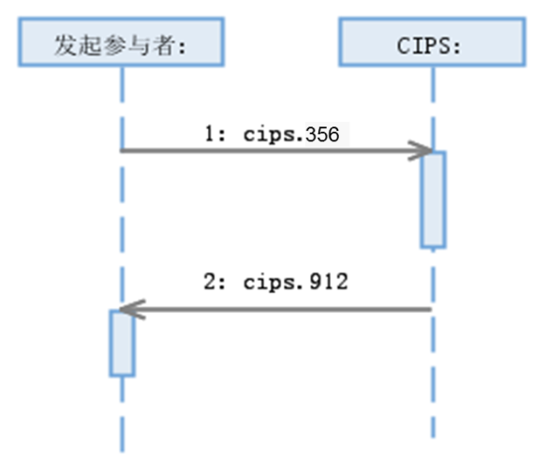
Participant:
- Example
  - RequestForPrewarningValueSetting <cips.354.001.01>
Message Instance:
<?xml version="1.0" encoding="UTF-8"?>
<Document xmlns="urn:swift:xsd:camt.011.001.05" xmlns:xsi="http://www.w3.org/2001/XMLSchema-instance">
<ModfyLmt>
<MsgHdr>
<MsgId>2014121700000066</MsgId>
<CreDtTm>2014-12-17T09:30:47</CreDtTm>
</MsgHdr>
<LmtDtls>
<LmtId>
<Cur>
<BilLmtCtrPtyId>
<FinInstnId>
<ClrSysMmbId>
<MmbId>BKCHCNBJXXX</MmbId>
</ClrSysMmbId>
</FinInstnId>
</BilLmtCtrPtyId>
<Tp>
<Cd>MULT</Cd>
</Tp>
</Cur>
</LmtId>
<NewLmtValSet>
<Amt>
<AmtWthCcy Ccy="CNY">10000000.00</AmtWthCcy>
</Amt>
<CdtDbtInd>CRDT</CdtDbtInd>
</NewLmtValSet>
</LmtDtls>
</ModfyLmt>
</Document>

