

CIPS Message Definition Report
Part 1: Business Information

V1.0.0
January 2021

Important Note: This Article is made out in both English and Chinese versions. We hereby set Chinese version as standard and English version as a reference should any conflicts occurred. If you have any questions, please contact us at bzb@cips.com.cn.

Revision Record
Version Number | Date | Revision Note | Scope
V1.0.0 | 26-10-2019 | [C]  CIPS Message Definition Report — Part 1: Business Information | All
Note: Change statuses are C — created, A — added, M — modified, and D — deleted.
Table of Contents

1 Introduction 1
1.1 Terms and Definitions 1
1.2 Abbreviations and Acronyms 1
1.3 Document Scope and Objectives 1
1.4 References 2
2 Scope and Functionality 2
2.1 Background 2
2.2 Scope 2
2.3 Groups of MessageDefinitions and Functionality 3
3 BusinessRoles and Participants 3
3.1 Information Business 3
4 BusinessProcess Description 4
4.1 Query/Response Process Description 4
4.2 Payment Status Query Process Description 4
4.3 Encrypted Information Notification Process Description 5
4.4 Process Description of Free Format Information Business 5
4.5 Charge Statement Process Description 5
5 Description of BusinessActivities 6
5.1 Query/Response 6
5.2 Payment Status Query 7
5.3 Encrypted Information Notification 8
5.4 Free Format Information Business 9
5.5 Charge Statement 11
6 BusinessProcesses 12
6.1 Query/Response 12
6.1.1 Normal Process of Query/Response 12
6.1.2 Special Process of Query/Response 13
6.2 Payment Status Query 15
6.2.1 Normal Process of Payment Status Query 15
6.2.2 Special Process of Payment Status Query 15
6.3 Encrypted Information Notification 16
6.3.1 Normal Process of Encrypted Information Notification 16
6.3.2 Special Process of Encrypted Information Notification 16
6.4 Free Format Information Business 18
6.4.1 Normal Process of Free Format Information Business 18
6.4.2 Special Process of Free Format Information Business 19
6.5 Charge Statement 20
7 Example 21
7.1 Query <cips.301.001.02> 21

- Introduction
  - Terms and Definitions
The terms involved in this document are defined as follows:
Term | Definition
BusinessRole | A BusinessRole represents an entity (or a class of entities) of an actual business.
Participant | A functional role played by a BusinessRole in a particular BusinessProcess or BusinessTransaction.
BusinessProcess | Business activities undefined but undertaken within a BusinessArea whereby each BusinessProcess fulfills one type of business activities and whereby a BusinessProcess may include and extend other BusinessProcesses.
BusinessTransaction | A particular solution that meets the communication requirements and the interaction requirements of a particular BusinessProcess and BusinessArea.
MessageDefinition | Formal description of the structure of a message instance.

The CIPS terms involved in this document are defined as follows:
Term | Description
Cross-border Interbank Payment System (CIPS) | CIPS provides fund clearing and settlement service for its Participants’ cross-border RMB payment transactions, financial market transactions, etc.
CIPS Direct Participant | CIPS Direct Participant refers to a domestic or an overseas institution that has a CIPS code and handles cross-border RMB payment and settlement businesses directly through CIPS. The operating agency of CIPS will open a CIPS account for each Direct Participant bank, and will also open a CIPS account for each Direct Participant FMI as required by prudent management.
CIPS Indirect Participant | CIPS Indirect Participant refers to a domestic or an overseas institution that has not opened a CIPS account but has a CIPS code and entrusts an appropriate CIPS Direct Participant to handle cross-border RMB payment and settlement businesses through CIPS.
Information Business | Information Business refers to the business in which CIPS and Participants transfer information to each other without direct fund settlement. It includes general information services and management information services.
Payment Business | Payment Business refers to credit transactions initiated or received by Participants through CIPS for fund settlement, including customer credit transfers, financial institution transfers and financial market transactions.

  - Abbreviations and Acronyms
Abbreviation/Acronyms | Definition
CIPS | Cross-border Interbank Payment System
FMI | Financial Market Infrastructure
  - Document Scope and Objectives
This document is the first part of the Remittance Message Definition Report (MDR) and describes the BusinessTransactions and underlying message set. For the sake of completeness, the document may also describe the BusinessActivities that are not in the scope of the BusinessProcesses covered in this document.
This document describes the following:
- the BusinessProcesses scope
- the BusinessRoles involved in these BusinessProcesses
The main objectives of this document are as follows:
- to explain the BusinessProcesses and BusinessActivities these messages have addressed
- to explain the BusinessProcesses and BusinessActivities these messages have addressed
- to give a high-level description of the BusinessProcesses and associated BusinessRoles
- to explain the BusinessProcesses and related Participants
- to present a list of MessageDefinitions
  - References
Document | Version | Date | Author
Message Exchange Standard for CNAPS2 | V1.4.7 | 05-2017 | China National Clearing Center, the People’s Bank of China
CIPS (Phase II) Requirements Specification | V1.0.0 | 05-2017 | China National Clearing Center, the People’s Bank of China
CIPS Message Exchange Standard V2.1.0 | V2.1.0 | 11-01-2019 | Payment System Development Center, China National Clearing Center, the People’s Bank of China
Requirements Specification for Multi-debit/credit Transfer by Clearing Institution | V0.5.0 | 01-2019 | China National Clearing Center, the People’s Bank of China

- Scope and Functionality
  - Background
This Message Definition Report covers a set of 10 messages developed by CIPS for business information.
  - Scope
This message set covers the BusinessProcesses of business information. The following 10 messages are used to describe the BusinessProcesses:
- Query (cips.301.001.02): Initiating Direct Participant sends this message to CIPS for querying the receiving agent or the sending agent about the questions in the business initiated or received previously.
- Response (cips.302.001.02): Receiving Direct Participant sends this message to CIPS for returning the query situation to Original Query Initiating Direct Participant.
- PaymentStatusQuery (cips.305.001.03): Direct Participants send this message to CIPS during the operation period for querying the processing status of related payment transactions and account operation orders.
- AnswerForPaymentStatusQuery (cips.306.001.03): CIPS returns the processing status of the queried business to Direct Participants through this message.
- EncryptedMessage (cips.307.001.01): Initiating Direct Participant sends this message to CIPS for transmitting certain information between Initiating Direct Participant and Receiving Direct Participant.
- AnswerForEncryptedMessage (cips.308.001.01): Receiving Direct Participant sends this message to CIPS for replying with the information data of original Initiating Direct Participant.
- FreeFormat (cips.309.001.01): This message without digital signature is used for information transmission between Direct Participants or between Direct Participants and CIPS.
- ChargeStatement (cips.611.001.01): CIPS sends a ChargeStatement message (cips.611) to all Direct Participants; upon receiving the message, the Participants reply to CIPS with a CommonConfirmation message (cips.900).
- CommonConfirmation (cips.900.001.01): Upon receiving a message from a Participant, CIPS notifies the Participant of the business processing result through this message or upon receiving a critical message from CIPS, a Participant sends this message to inform CIPS that the related message has been processed.
- MessageAbandonNotice (cips.912.001.01): Upon receiving a message from a Participant, if CIPS can neither carry out any business processing nor reply with a business-level CommonConfirmation message, CIPS will automatically abandon the accepted message , and send this message to the sender of the accepted message.
  - Groups of MessageDefinitions and Functionality
MessageDefinition | ISO 20022 Identifier | CIPS Identifier
Query | camt.035.001.03 | cips.301.001.02
Response | camt.036.001.03 | cips.302.001.02
PaymentStatusQuery | camt.005.001.06 | cips.305.001.02
AnswerForPaymentStatusQuery | camt.006.001.07 | cips.306.001.03
EncryptedMessage | / | cips.307.001.01
AnswerForEncryptedMessage | / | cips.308.001.01
FreeFormat | / | cips.309.001.01
ChargeStatement | camt.086.001.01 | cips.611.001.01
CommonConfirmation | camt.025.001.03 | cips.900.001.01
MessageAbandonNotice | / | cips.912.001.01
- BusinessRoles and Participants
A BusinessRole represents an entity (or a class of entities) of the real world, physical or legal, including a person or corporation. Examples of BusinessRoles: “Financial Institution”., and so on.
A Participant is a functional role played by a BusinessRole in a particular BusinessProcess or BusinessTransaction. Examples of Participants: the “user” of a system, “debtor”, “investor”, and so on.
The relationship between BusinessRoles and Participants is many-to-many. A BusinessRole can act as different Participants at different moments or at the same time. For example, a BusinessRole can be the “user” of a system, a “debtor” and an “investor” at the same time. In addition, different BusinessRoles can be involved as the same Participant.
  - Information Business
The BusinessRoles and Participants in information business are described below.
Participant and BusinessRole Definitions
Participant | Definition
CIPS | Cross-border Interbank Payment System
Initiating Direct Participant | A direct participant that initiated the business
Receiving Direct Participant | A direct participant that received the business
FMI | Financial market infrastructure
BusinessRole | Definition
CIPS Participant | A participant that directly interacts with CIPS
Clearing System | Cross-border Interbank Payment System

Participant and BusinessRole Matrix
BusinessRole  Participant | CIPS Participant | Clearing System
CIPS |  | √
Initiating Direct Participant | √
Receiving Direct Participant | √
FMI | √

- BusinessProcess Description
This section describes the BusinessProcesses. Description of the BusinessProcesses and the information in the BusinessProcesses can help to identify relationships between the BusinessRoles.

  - Query/Response Process Description
The specific process of Query/Response is shown in the figure below:
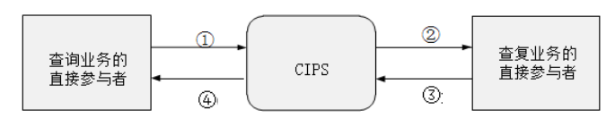
Query Direct Participant
Response Direct Participant
① Query Direct Participant initiates a query. Query Direct Participant should send a Query message to CIPS according to the specified message format and requirements.
② CIPS receives and forwards the Query message. Upon receiving the Query message, CIPS performs message format checks, necessary business checks and double accounting checks. After the check, CIPS forwards the Query message to Response Direct Participant, and replies to the Direct Participant initiating the query with a CommonConfirmation message.
③ Response Direct Participant sends a Response message to CIPS. Upon receiving the Query message forwarded by CIPS, Response Direct Participant finds out the situation and reason. Upon reviewing, Response Direct Participant sends a Response message to CIPS according to the specified message format and requirements.
④ CIPS receives and forwards the Response message. Upon receiving the Response message, CIPS performs message format checks, necessary business checks and double accounting checks, and matches the Query message with the Response message. If the matching succeeds, CIPS forwards the Response message to Query Direct Participant, and replies to Response Direct Participant with a CommonConfirmation message. If the matching fails, CIPS sends a RejectionNotice message to Response Direct Participant. CIPS establishes Query and Response Register and allows multiple responses to one same query. An Indirect Participant sends a Response message through a Direct Participant.
  - Payment Status Query Process Description
The specific process of payment status query is shown in the figure below:
Initiating Direct Participant

① The Direct Participant initiating the payment sends a PaymentStatusQuery message to CIPS according to the specified format and requirements.
② Upon receiving a PaymentStatusQuery message, CIPS queries the receiving time, forwarding time and transaction status of the payment in CIPS. The processing status of the queried payment is returned to the Direct Participant through an AnswerForPaymentStatusQuery message (cips.306).
  - Encrypted Information Notification Process Description
The process of general signature information notification is shown in the figure below:
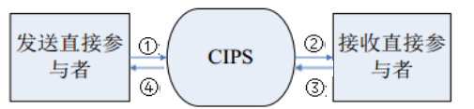
Initiating Direct Participant
Receiving Direct Participant
① Initiating Direct Participant sends an EncryptedMessage message to CIPS according to the specified format and requirements.
② Upon receiving the EncryptedMessage message from Initiating Direct Participant, CIPS performs message format checks, necessary business checks (including digital signature verification) and double accounting checks. After the checks, CIPS forwards the EncryptedMessage message to Receiving Direct Participant.
③ Receiving Direct Participant sends an AnswerForEncryptedMessage message; upon receiving the AnswerForEncryptedMessage message from Receiving Direct Participant, CIPS performs related checks.
④ After the message passes related checks, CIPS forwards the AnswerForEncryptedMessage message to Initiating Direct Participant.
  - Process Description of Free Format Information Business
The specific process of free format information business is shown in the figure below:
Specific Direct Participants/All Direct Participants
Initiating Direct Participant
Receiving Direct Participant

① CIPS publishes announcement information to specific Direct Participants/all Direct Participants through broadcasting a FreeFormat message.
② Initiating Direct Participant sends a point-to-point FreeFormat message to CIPS or CIPS forwards the message to Receiving Direct Participant.
  - Charge Statement Process Description
The specific process of Charge Statement is shown in the figure below:
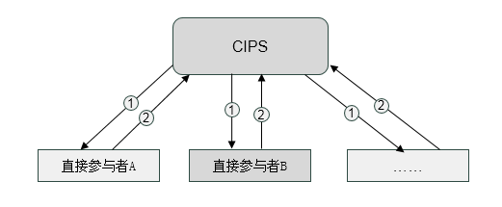
Direct Participant A
Direct Participant B
The process of Charge statement is as follows:
① CIPS completes Charge within the Charge interval, and then sends a ChargeStatement message to all Direct Participants.
② Upon receiving the ChargeStatement message, the Direct Participants reply to CIPS with a CommonConfirmation message.
- Description of BusinessActivities
This section presents the different BusinessActivities within each BusinessProcess. The BusinessActivities of a process are described with an activity diagram. The following is an introduction to the activity diagram.
- describes the general lifecycle of a business process;
- Start Point  shows where the lifecycle of the business process commences, and End Point  shows where the lifecycle of the business process ends;
- Lozenge (or Diamond) indicates that a choice between several actions can be made;
- There are activity streamlines between Participants;
- Information in the BusinessActivities is transmitted from one Participant to another.
  - Query/Response
Initiating Direct Participant sends a Query message to CIPS. After the message passes CIPS checks, CIPS forwards the Query message to Receiving Direct Participant, and returns the business processing results to Initiating Direct Participant through a CommonConfirmation message; upon receiving and checking the Query message，Receiving Direct Participant sends a Response message; after the Response message passes CIPS checks, CIPS forwards the Response message to Initiating Direct Participant.
Initiating Direct Participant
Yes
Yes
No
No
No
No
Send a Query message to CIPS
Receive the MessageAbandonNotice message
Receive the CommonConfirmation message
Receive the Response message
Receive the Query message
Message review
Send a MessageAbandonNotice message
Pass message format check and double accounting check or not

Pass business legality check and digital signature validity check or not
Send a CommonConfirmation message
Send the Response message to Receiving Direct Participant
Receive the Response message
Message review
Pass message format check and double accounting check or not
Send a MessageAbandonNotice message
Pass business legality check and digital signature validity check or not
Send a CommonConfirmation message
Send the Response message to Initiating Direct Participant
Receiving Direct Participant
Receive the Response
message
Send a Response message to CIPS
Receive the MessageAbandonNotice message
Receive the CommonConfirmation message
  - Payment Status Query
Initiating Direct Participant sends a PaymentStatusQuery message for querying the processing situation of payment transactions at CIPS; upon receiving the PaymentStatusQuery message, CIPS returns the processing status of the queried business to Initiating Direct Participant through an AnswerForPaymentStatusQuery message.
Yes
No
Receive the PaymentStatusQuery message
Pass message format check and double accounting check or not
Initiating Direct Participant
Send a PaymentStatusQuery message to CIPS
Receive the MessageAbandonNotice message
Receive the AnswerForPaymentStatusQuery message
Send a PaymentStatusQuery message to CIPS
Message review
Send a MessageAbandonNotice message
Send a AnswerForPaymentStatusQuery message

  - Encrypted Information Notification
An EncryptedMessage can be used to transmit the information data of payment notice, contact, letter of credit, collection, letter of guarantee and other matters enclosed with files or high security encryption between Direct Participants.
Initiating Direct Participant sends an EncryptedMessage to CIPS; without any checks on the packed content, CIPS forwards the message to Receiving Direct Participant, and sends a CommonConfirmation message to Initiating Direct Participant; Receiving Direct Participant responds to the EncryptedMessage with an AnswerForEncryptedMessage.
Initiating Direct Participant
Send a EncryptedMessage message to CIPS
Receive the MessageAbandonNotice message
Receive the CommonConfirmation message
Receive the AnswerForEncryptedMessage message
Receive the EncryptedMessage message
Message review
Pass message format check and double accounting check or not
Send a MessageAbandonNotice message
Pass business legality check and digital signature validity check or not
Send a CommonConfirmation message
Send the EncryptedMessage message to Business Acceptor
Receive the AnswerForEncryptedMessage message
Message review
Pass message format check and double accounting check or not
Send a MessageAbandonNotice message
Pass business legality check and digital signature validity check or not
Send a CommonConfirmation message
Send the AnswerForEncryptedMessage message to Initiating Direct Participant

Receiving Direct Participant
Receive the EncryptedMessage message
Send a AnswerForEncryptedMessage message to CIPS
Receive the MessageAbandonNotice message
Receive the CommonConfirmation message
Yes
No
Yes
No
No
No
Yes
Yes

  - Free Format Information Business
Freeformat messages are used for notification and communication among Participants or between Participants and CIPS. Participants can only send point-to-point FreeFormat messages. CIPS can broadcast FreeFormat messages to all Participants.

CIPS sends a FreeFormat message to specific Participants or all Participants.
Initiating Participants
Send a FreeFormat message to specific Participants or all Participants
Receive the FreeFormat message

Participants send a FreeFormat message to CIPS.
Participants
Send a FreeFormat message to CIPS
Receive the CommonConfirmation message
Receive the FreeFormat message
Send a CommonConfirmation message
An Initiating Participant sends a FreeFormat message; after the message passes the checks, CIPS forwards the message to the Receiving Participant, and replies to the Initiating Participant with a CommonConfirmation message.

Initiating Participant
Send a FreeFormat message to CIPS
Receive the MessageAbandonNotice message
Receive the CommonConfirmation message
Receive the FreeFormat message
Message review
Pass message format check and double accounting check or not
Send a MessageAbandonNotice message
Pass business legality check and digital signature validity check or not
Send a CommonConfirmation message
Send the FreeFormat message to Receiving Participant
Receiving Participant
Receive the FreeFormat message
No
Yes
Yes
No

  - Charge Statement
After the last working day of each month which is the CLSD period on the first working day of the next month, CIPS calculates the monthly message charges of Participants with Direct Participants as units according to the specified message rate and daily business data, considers monthly operating costs (if it is the end of the year, the charges should also include the annual fee of the next year), completes the charge within the charge interval, and issues a ChargeStatement message to Direct Participants.
Receiving Direct Participant
Send a ChargeStatement message to all Direct Participants
Receive the CommonConfirmation message
Receive the ChargeStatement message
Send a CommonConfirmation message
- BusinessProcesses
This section describes the message flows based on the following activity diagrams to show the specific communication processes in the BusinessProcesses or BusinessTransactions.
  - Query/Response
Initiating Direct Participant sends a Query message to CIPS. After the message passes CIPS checks, CIPS forwards the message to Receiving Direct Participant, and returns the business processing results to Initiating Direct Participant through a CommonConfirmation message; upon receiving the Query message, Information Receiver sends a Response message after successful processing; after the message passes CIPS checks, CIPS forwards it to Initiating Direct Participant, and returns the business processing results to Initiating Direct Participant through a CommonConfirmation message.
    - Normal Process of Query/Response
Initiating Direct Participant sends a Query message; after business checks, CIPS forwards the Query message to Receiving Direct Participant, and replies to Initiating Direct Participant with a CommonConfirmation message. Upon receiving the Query message, Receiving Direct Participant replies to CIPS with a Response message after successful processing; after the message passes the checks, CIPS forwards the message to Initiating Direct Participant, and replies to Receiving Direct Participant with a CommonConfirmation message. Participants can give multiple responses to one same query.
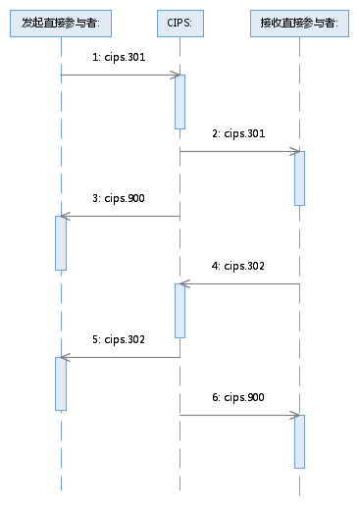
Initiating Direct Participant:
Receiving Direct Participant:
    - Special Process of Query/Response
Initiating Direct Participant sends a Query message. If the Query message fails to pass the business checks (e.g. no login or no permission, etc.), CIPS replies with a CommonConfirmation message to inform Initiating Participants of the reasons for rejecting this message.
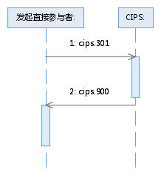
Initiating Direct Participant:

Receiving Direct Participant replies with a Response message. If this message fails to pass the business checks, CIPS replies with a CommonConfirmation message to inform Receiving Direct Participant of the reasons for rejecting this message.
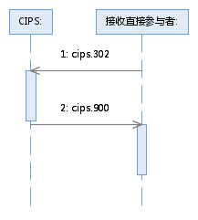
Receiving Direct Participant:
CIPS abandons a Response message sent by a Participant due to nonexistence of DirectParticipantIdentification, invalid DirectParticipantIdentification, wrong message format or double accounting.
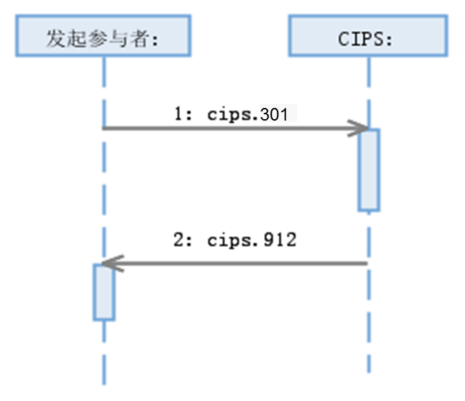
InitiatingParticipant:

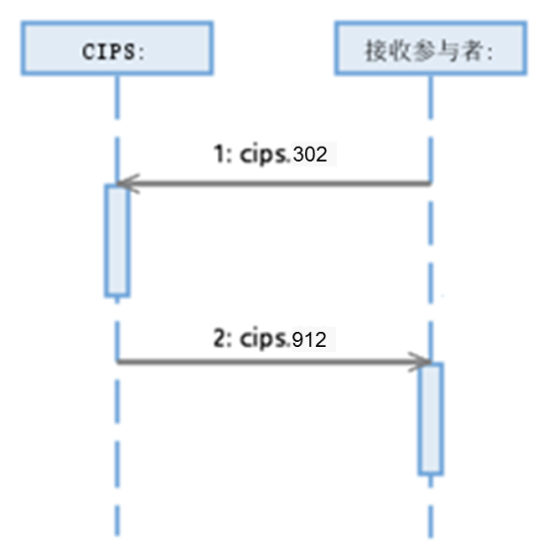
Receiving Participant:

  - Payment Status Query
Initiating Direct Participant sends a PaymentStatusQuery message for querying the processing situation of payment transactions at CIPS; upon receiving the PaymentStatusQuery message, CIPS returns the processing status of the queried payment transactions to Initiating Direct Participant through an AnswerForPaymentStatusQuery message.
    - Normal Process of Payment Status Query
After Participants send a PaymentStatusQuery message, whether CIPS succeeds in processing the message or the message fails to pass CIPS business checks (e.g. no login or no permission, etc), CIPS replies with an AnswerForPaymentStatusQuery message.
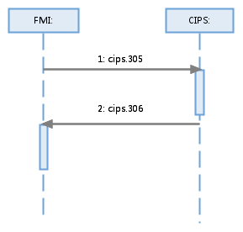
    - Special Process of Payment Status Query
CIPS abandons a PaymentStatusQuery message sent by a Participant due to nonexistence of DirectParticipantIdentification, invalid DirectParticipantIdentification, unfound original business, wrong message format or double accounting.
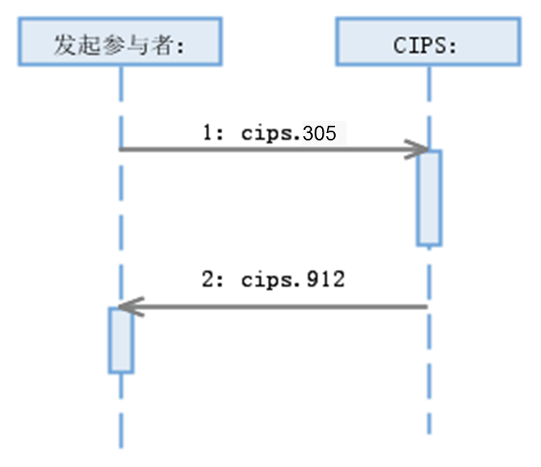
Initiating Participant:

  - Encrypted Information Notification
Initiating Direct Participant sends an EncryptedMessage message to CIPS; without any checks on the packed content, CIPS forwards the message to Receiving Direct Participant, and sends a CommonConfirmation message to Initiating Direct Participant; Receiving Direct Participant responds to the EncryptedMessage message with an AnswerForEncryptedMessage message.
    - Normal Process of Encrypted Information Notification
Initiating Direct Participant sends an EncryptedMessage message; after business checks, CIPS forwards the message to Receiving Direct Participant, and replies to Initiating Direct Participant with a CommonConfirmation message. Upon receiving the EncryptedMessage message, Receiving Direct Participant replies to CIPS with an AnswerForEncryptedMessage message after successful processing; after the message passes the checks, CIPS forwards the message to Initiating Direct Participant, and replies to Receiving Direct Participant with a CommonConfirmation message.
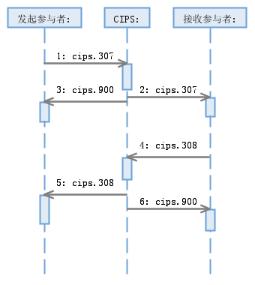
InitiatingParticipant:
Receiving Participant:

    - Special Process of Encrypted Information Notification
The business initiated by a Participant is rejected by CIPS due to the error(s) founds in business checks.
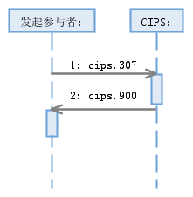
Initiating Participant:
CIPS abandons a message sent or replied by a Participant due to nonexistence of DirectParticipantIdentification, invalid DirectParticipantIdentification, unfound original business, wrong message format or double accounting.
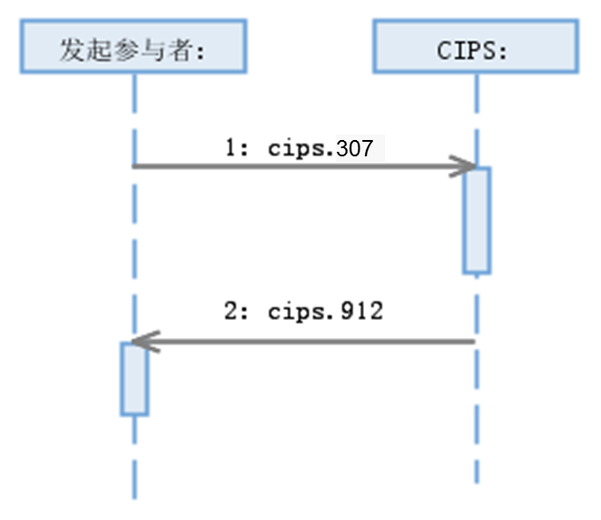
Initiating Participant:
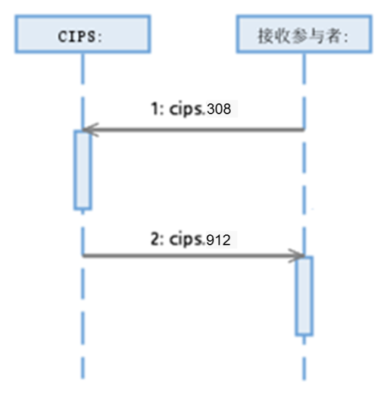
Receiving Participant:

  - Free Format Information Business
FreeFormat messages are used for notification and communication among Participants or between Participants and CIPS. Participants can only send point-to-point FreeFormat message. CIPS can broadcast FreeFormat messages to all Participants.
    - Normal Process of Free Format Information Business
CIPS sends a FreeFormat message to specific Participants.
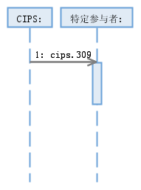
Specific Participants:
All Participants:
CIPS sends a FreeFormat message to all Participants.
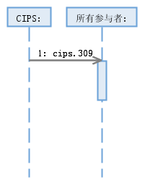

Participants send a FreeFormat message to CIPS.
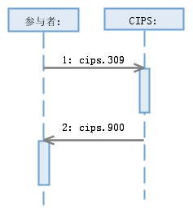
Participants:

Initiating Direct Participant sends a FreeFormat message; after the message passes the checks, CIPS forwards the message to Receiving Direct Participant, and replies to Initiating Direct Participant with a CommonConfirmation message.
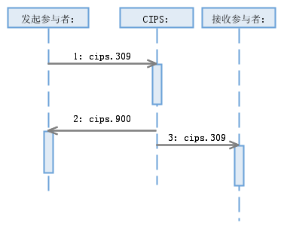
Initiating Participant:
Receiving Participant:
    - Special Process of Free Format Information Business
Initiating Direct Participant sends a FreeFormat message; if the message fails to pass the checks, CIPS replies to Initiating Direct Participant with a CommonConfirmation message.
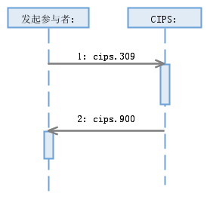
Initiating Participant:

CIPS abandons the business message sent by Participants due to nonexistence of DirectParticipantIdentification, wrong message format or double accounting.
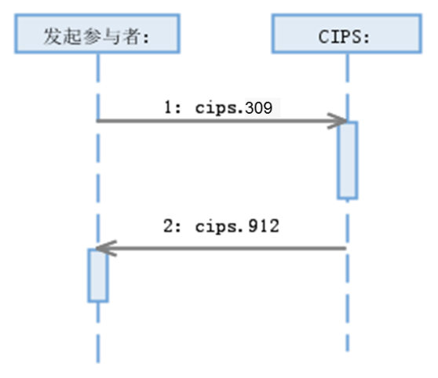
Initiating Participant
  - Charge Statement
CIPS sends a ChargeStatement message to all Direct Participants. Upon receiving this message, Receiving Direct Participant replies to CIPS with a CommonConfirmation message.
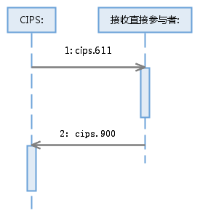
Receiving Direct Participant:
- Example
  - Query <cips.301.001.02>
Message Instance:
<PrtryFrmtInvstgtn>
<Assgnmt>
<Id>2014121100001111</Id>
<Assgnr>
<Agt>
<FinInstnId>
<ClrSysMmbId>
<MmbId>CITICNSXBJG</MmbId>
</ClrSysMmbId>
</FinInstnId>
<BrnchId>
<Id>CITICNSXBJG</Id>
</BrnchId>
</Agt>
</Assgnr>
<Assgne>
<Agt>
<FinInstnId>
<ClrSysMmbId>
<MmbId>HASECNSHBEJ</MmbId>
</ClrSysMmbId>
</FinInstnId>
<BrnchId>
<Id>HASECNSHBEJ</Id>
</BrnchId>
</Agt>
</Assgne>
<CreDtTm>2014-12-11T09:30:47</CreDtTm>
</Assgnmt>
<Case>
<Id>2014121100011122</Id>
<Cretr>
<Agt>
<FinInstnId>
<ClrSysMmbId>
<MmbId>CITICNSXBJG</MmbId>
</ClrSysMmbId>
</FinInstnId>
</Agt>
</Cretr>
</Case>
<PrtryData>
<Tp>cips.301.001.01</Tp>
<Data>
<Data>
<OrgnlMsgNmId>cips.111.001.01</OrgnlMsgNmId>
<OrgnlEndToEndId>12345678</OrgnlEndToEndId>
<IntrBkSttlmAmt Ccy="CNY">50000.00</IntrBkSttlmAmt>
<Cntt>Whether the status is ACSC or not?</Cntt>
</Data>
</Data>
</PrtryData>
</PrtryFrmtInvstgtn>
</Document>

