

CIPS Message Definition Report
Part 1: System Management

V1.0.0
January 2021

Important Note: This Article is made out in both English and Chinese versions. We hereby set Chinese version as standard and English version as a reference should any conflicts occurred. If you have any questions, please contact us at bzb@cips.com.cn.

Revision Record
Version Number | Date | Revision Note | Scope
V1.0.0 | 26-10-2019 | [C]  CIPS Message Definition Report — Part 1: System Management | All
Note: Change statuses are C — created, A — added, M — modified, and D — deleted.

Table of Contents

1 Introduction 1
1.1 Terms and Definitions 1
1.2 Abbreviations and Acronyms 1
1.3 Document Scope and Objectives 1
1.4 References 2
2 Scope and Functionality 2
2.1 Background 2
2.2 Scope 2
2.3 Groups of MessageDefinitions and Functionality 2
3 BusinessRoles and Participants 3
3.1 System Management Business 3
4 BusinessProcess Description 3
4.1 System Status Management Processes Description 3
4.2 Participant Status Management Process Description 5
4.2.1 Login/Logoff 5
4.2.2 Forced Offline 6
4.2.3 Participant Status Change 6
5 Description of BusinessActivities 7
5.1 System Status Management 7
5.1.1 System Status Change Notification 7
5.2 Participant Status Management 8
5.2.1 Request/Answer for Login/Logoff 8
5.2.2 Forced Offline Notification 9
5.2.3 Participant Status Change Notification 10
6 BusinessProcesses 10
6.1 System Status Management 10
6.1.1 System Status Change Notification 10
6.2 Participant Status Management 11
6.2.1 Request/Answer for Login/Logoff 11
6.2.2 Forced Offline Notification 11
6.2.3 Participant Status Change Notification 11
7 Example 12
7.1 SystemStatusChangeNotice <cips.801.001.01> 12

- Introduction
  - Terms and Definitions
The terms involved in this document are defined as follows:
Term | Definition
BusinessRole | A BusinessRole represents an entity (or a class of entities) of an actual business.
Participant | A functional role played by a BusinessRole in a particular BusinessProcess or BusinessTransaction.
BusinessProcess | Business activities undefined but undertaken within a BusinessArea whereby each BusinessProcess fulfills one type of business activities and whereby a BusinessProcess may include and extend other BusinessProcesses.
BusinessTransaction | A particular solution that meets the communication requirements and the interaction requirements of a particular BusinessProcess and BusinessArea.
MessageDefinition | Formal description of the structure of a message instance.

The CIPS terms involved in this document are defined as follows:
Term | Description
Cross-border Interbank Payment System (CIPS) | CIPS provides fund clearing and settlement service for its Participants’ cross-border RMB payment transactions, financial market transactions, etc.
CIPS Direct Participant | CIPS Direct Participant refers to a domestic or an overseas institution that has a CIPS code and handles cross-border RMB payment and settlement businesses directly through CIPS. The operating agency of CIPS will open a CIPS account for each Direct Participant bank, and will also open a CIPS account for each Direct Participant FMI as required by prudent management.
CIPS Indirect Participant | CIPS Indirect Participant refers to a domestic or an overseas institution that has not opened a CIPS account but has a CIPS’s bank code and entrusts an appropriate CIPS Direct Participant to handle cross-border RMB payment and settlement businesses through CIPS.
Initiating | Initiating refers to an individual or institution that initially creates a request for payment or information.
Receiver | Receiver refers to an individual or institution that ultimately receives a request for payment or information.
  - Abbreviations and Acronyms
Abbreviation/Acronyms | Definition
CIPS | Cross-border Interbank Payment System

  - Document Scope and Objectives
This document is the first part of the Remittance Message Definition Report (MDR) and describes the BusinessTransactions and underlying message set. For the sake of completeness, the document may also describe the BusinessActivities that are not in the scope of the BusinessProcesses covered in this document.
This document describes the following:
- the BusinessProcesses scope
- the BusinessRoles involved in these BusinessProcesses
The main objectives of this document are as follows:
- to explain the BusinessProcesses and BusinessActivities these messages have addressed
- to explain the BusinessProcesses and BusinessActivities these messages have addressed
- to give a high-level description of the BusinessProcesses and associated BusinessRoles
- to explain the BusinessProcesses and related Participants
- to present a list of MessageDefinitions
  - References
Document | Version | Date | Author
Message Exchange Standard for CNAPS2 | V1.4.7 | 05-2017 | China National Clearing Center, the People’s Bank of China
CIPS (Phase II) Requirements Specification | V1.0.0 | 05-2017 | China National Clearing Center, the People’s Bank of China
CIPS Message Exchange Standard V2.1.0 | V2.1.0 | 11-01-2019 | Payment System Development Center, China National Clearing Center, the People’s Bank of China
Requirements Specification for Multi-debit/credit Transfer by Clearing Institution | V0.5.0 | 01-2019 | China National Clearing Center, the People’s Bank of China
- Scope and Functionality
  - Background
This Message Definition Report covers a set of 7 messages developed by CIPS for system management.
  - Scope
This message set covers the BusinessProcesses of system management. The following 7 messages are used to describe the BusinessProcesses:
- SystemStatusChangeNotice (cips.801.001.01): CIPS sends this message to all Direct Participants. Upon receiving this message, the Participants reply to CIPS with a CommonConfirmation (cips.900) message.
- ParticipantStatusChangeNotice (cips.803.001.01): CIPS sends this message to all Participants. Upon receiving this message, the Participants reply to CIPS with a CommonConfirmation (cips.900) message.
- CommonConfirmation (cips.900.001.01): Upon receiving a message from a Participant, CIPS replies with the processing result in cips.900, or vice versa.
- RequestForLogin/Logoff (cips.805.001.01): Participants send this message to CIPS for Login/Logoff operation. CIPS sends a AnswerForLogin/Logoff (cips.806) or MessageAbandonNotice (cips.912) message to Participants.
- AnswerForLogin/Logoff (cips.806.001.01): Upon receiving a RequestForLogin/Logoff message (cips.805) from Participants, CIPS conducts Login/Logoff operation. CIPS sends this message to Participants either because no error is found during checking or the message fails to pass business checks.
- MessageAbandonNotice (cips.912.001.01): CIPS sends a cips.912 to abandon received message if CIPS can neither carry out any business processing nor reply with a business-level CommonConfirmation message.
- ForcedOfflineNotice (cips.807.001.01): CIPS sends this message to notify related Particaipant that the Participant has been forcibly logged off from the system.
  - Groups of MessageDefinitions and Functionality
MessageDefinition | ISO 20022 Identifier | CIPS Identifier
SystemStatusChangeNotice | / | cips.801.001.01
ParticipantStatusChangeNotice | / | cips.803.001.01
CommonConfirmation | camt.025.001.03 | cips.900.001.01
RequestForLogin/Logoff | / | cips.805.001.01
AnswerForLogin/Logoff | / | cips.806.001.01
MessageAbandonNotice | / | cips.912.001.01
ForcedOfflineNotice | / | cips.807.001.01
- BusinessRoles and Participants
A BusinessRole represents an entity (or a class of entities) of the real world, physical or legal, including a person or corporation. Examples of BusinessRoles: “Financial Institution”, and so on.
A Participant is a functional role played by a BusinessRole in a particular BusinessProcess or BusinessTransaction. Examples of Participants: the “user” of a system, “debtor”, “investor”, and so on.
The relationship between BusinessRoles and Participants is many-to-many. A BusinessRole can act as different Participants at different moments or at the same time. For example, a BusinessRole can be the “user” of a system, a “debtor” and an “investor” at the same time. In addition, different BusinessRoles can be involved as the same Participant.
  - System Management Business
The BusinessRoles and Participants in system management business are described below.
Participant and BusinessRole Definitions
Participant | Definition
CIPS | Cross-border Interbank Payment System
Initiating Direct Participant | A direct participant that sends a payment order to CIPS
Receiving Direct Participant | A direct participant that receives a payment order from CIPS and makes payment to CIPS according to the payment order
BusinessRole | Definition
Clearing System | Cross-border Interbank Payment System
CIPS Participant | A participant that directly interacts with CIPS

Participant and BusinessRole Matrix
BusinessRole  Participant | Clearing System | CIPS Participant
CIPS | √
Receiving Direct Participant |  | √
Initiating Direct Participant |  | √

- BusinessProcess Description
This section describes the BusinessProcesses. Description of the BusinessProcesses and the information in the BusinessProcesses can help to identify relationships between the BusinessRoles.
  - System Status Management Processes Description
CIPS operates on national legal working days by default, and its working days are determined according to the Gregorian calendar. Please refer to SystemStatusChangeNotice message for the specific working days. The operation of CIPS on each working day is divided into seven phases (statuses): CLSD, ACTV, SUSP, CLSG, NTAC, NTSP and NTCS. CIPS operates for 5*24+4 hours, that is to say, Monday to Friday is the normal working days of the system. Business processing is divided into daytime session and nighttime session. Daytime session runs from 9:00 to 17:00 on T day (calendar day), and nighttime session runs from 17:00 on T day to 8:00 on T+1 day. Seamless connection is realized between daytime session and nighttime session. CIPS does not operate on weekends and holidays. On the first working days after weekends and holidays (hereinafter referred to as special working days), the running time of daytime session will start 4 hours in advance, and the starting time is 5:00.
CIPS Direct Participants conduct initial prefunding through HVPS in daytime session, and obtain liquidity through reserved prefunding and initial prefunding in daytime session. Reserved prefunding is adopted for the nighttime session so as to guarantee that CIPS businesses will not be interrupted during the period when HVPS is not available (17:30-20:30). CIPS Direct Participants can increase their frozen funds from 16:00 to 17:00 (SUSP time point of CIPS) to reach the minimum capital injection limit for nighttime session. After CIPS enters the nighttime session, participants can reduce their frozen funds. CIPS supports participants to increase or reduce their reserved prefunding values at any time so as to ensure the liquidity required for the system operation.
1. CLSD phase:
8:30-9:00 is CLSD phase of CIPS. After the NTCS phase on the previous working day, CIPS switches the system working day, enters the CLSD status for next working day, and then archives and initializes the accounts successively; CIPS participant information becomes effective; CIPS public parameters become effective; expiration reminder notice is sent for digital certificates that are about to expire; business statistics is made for the previous day, and billing statement is issued if participants’ billing is conducted on the first working day at the beginning of a month. Then the system stops in this status, at which time system maintenance, data archiving and cleaning-related action can be carried out.
CIPS automatically opens the capital injection window to accept the capital injection transactions of participants until CIPS enters the ACTV phase.
On special working days, 4:30-5:00 is the CLSD phase of CIPS.
2. ACTV phase:
9:00-17:00 is the ACTV phase of CIPS. After entering the daytime session at 9:00 every day, CIPS closes the capital injection window (as described for the CLSD phase), updates the capital injection status of the participants whose capital injection amounts are not less than the sum of minimum capital injection limit plus netted capital injection quota to FDRC. At this time, CIPS concentrates on the processing of cross-border payment transactions, information services and fund adjustment services. After entering the daytime session, the participants whose prefunding has not been resoundingly completed can continue their funding until it is completed. Half an hour before entering the SUSP phase, a SystemStatusChangeNotice message containing the business cut-off warning will be sent to all participants to inform them to prepare for business cut-off.
On special working days, 5:00-17:00 is the ACTV phase of CIPS.
3. SUSP phase:
CIPS enters the SUSP phase at 17:00 every day, and automatically enters the CLSG phase after the switching.
4. CLSG phase:
After the CLSG phase, CIPS automatically returns the payments pending for settlement; after the completion of return, CIPS closes out accounts; after that, CIPS waits for HVPS end-of-day processing and reconciliation; after the completion of reconciliation with HVPS, CIPS checks whether closing out is completed; then, CIPS conducts trial balancing for accounts kept in the system; after confirmation, CIPS conducts reconciliation with participants; after that, CIPS automatically enters the NTAC phase.
5. NTAC phase:
17:00-8:00 (next working day) is NTAC phase of CIPS. Direct Participants can increase their frozen funds from 16:00 to 17:00 (the time point at which CIPS enters the SUSP phase) to reach the minimum capital injection limit for the nighttime session. CIPS updates the capital injection status of the participants whose capital injection amounts are not less than the sum of minimum capital injection limit plus netted capital injection quota to FDRC. At this time, CIPS concentrates on the processing of cross-border payment transactions, information services and fund adjustment services.
17:00-20:30 is available for business processing with the frozen funds. The participants whose prefunding has not been resoundingly completed can continue to increase their frozen funds before HVPS enters the daytime session of next working day until their funding is completed. Once HVPS enters the daytime of next working day, the frozen funds of CIPS Direct Participants will be automatically transferred into the account of CIPS at HVPS. 20:30-8:00 (next working day) is available for business processing with the available funds.
Half an hour before entering the NTSP phase, a SystemStatusChangeNotice message containing the business cut-off warning will be sent to all participants to inform them to prepare for business cut-off.
6. NTSP phase:
CIPS enters the NTSP phase at 8:00 every day, and automatically enters the NTCS phase after the switching.
7. NTCS phase:
After entering the NTCS phase, CIPS automatically returns the payments pending for settlement; after the completion of return, CIPS closes out accounts; after that, CIPS conducts pre-reconciliation with HVPS; after that, CIPS checks whether closing out is completed; then, CIPS conducts trial balancing for accounts kept in the system; after confirmation, CIPS conducts reconciliation with participants; after that, CIPS automatically enters the CLSD phase of next working day.
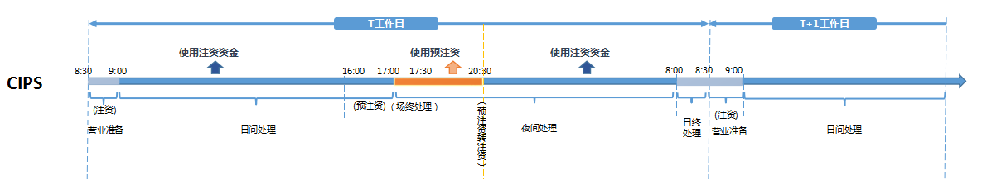
T working day
Use the available fund
(Initial prefunding)
CLSD
ACTV
Use the frozen fund
(Reserved prefunding)
(CLSG)
(Change of frozen fund to available fund)
T+1 working day
Use the available fund
NTAC
ACTV
ACTV
(Initial prefunding)
CLSD
ACTV

In order to meet the processing needs of RMB cross-border payment transactions, the operation time and working day time interval schedule of CIPS should be adjusted flexibly so as to effectively meet the fund clearing requirements of overseas participating institutions in different time zones.
System status change is shown in the figure below:
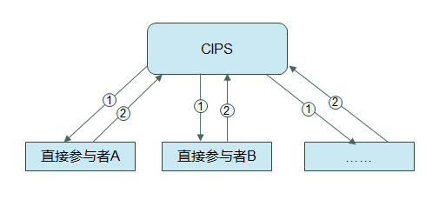
Direct Participant A
Direct Participant B
The process of status change management is as follows:
① When the system status changes, CIPS will send a SystemStatusChangeNotice to all Direct Participants.
② Upon receiving this message, the Direct Participants will reply to CIPS with a CommonConfirmation message.
  - Participant Status Management Process Description
    - Login/Logoff
Each Participant can log in or log off from CIPS. If a Participant needs to perform system maintenance or is temporarily unable to send and receive business messages due to any other reason, the Participant can set its status in CIPS as Logoff for not sending and receiving business messages any longer. When ready to send and receive business messages after maintenance, the Participant can log in CIPS again.
Login/logoff is shown in the figure below:
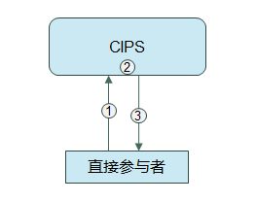
Direct Participant
The process of login/logoff is as follows:
① When a Participant needs to log in or log off from the system, the Participant sends a RequestForLogin/Logoff message to CIPS.
② CIPS checks the message.
③ When CIPS finds no error in the message during checking or the message fails to pass CIPS business checks (e.g. no login or no permission, etc.), CIPS sends an AnswerForLogin/Logoff message to the Participant; in case of nonexistence of DirectParticipantIdentification, invalid DirectParticipantIdentification, wrong message format or double accounting, CIPS abandons the message sent by the Participant, and sends a MessageAbandonNotice message to the Participant.
    - Forced Offline
When CIPS needs system maintenance, all Direct Participants can be forced offline.
Forced offline is shown in the figure below:
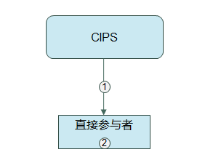
Direct Participants
The process of forced offline is as follows:
① CIPS sends a ForcedOffline message to Direct Participants to inform that the Participants have been forcibly logged off from the system (excluding forbidden login).
② Upon receiving the message, the Participants change their inner-bank system logging status to Logoff.
    - Participant Status Change
When a Participant cannot send and receive business messages due to system failure, the Participant should notify CIPS outside the system. CIPS will set the Participant’s status as DSBL on the management interface, broadcast the change to all Direct Participants and reject the business messages sent by other Participants to the disabled Participant; then the disabled Participant should not send any business message. When the failure is removed, the Participant should notify CIPS again. CIPS will set the Participant’s status to normal and broadcast the change to all Direct Participants; then the previously disabled but currently enabled Participant can send and receive business messages again.
Participant status change is shown in the figure below:
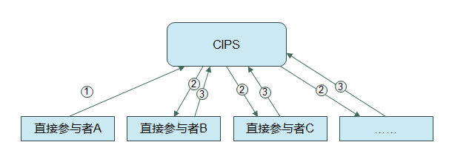
Direct Participant A
Direct Participant B
Direct Participant C
The process of participant status change is as follows:
① When Direct Participant A needs to change its status in CIPS, the Participant notifies CIPS outside the system.
② CIPS sends Direct Participant A’s status in CIPS to all other Participants.
③Upon receiving the status, all other Participants send a CommonConfirmation message to CIPS.
- Description of BusinessActivities
This section presents the different BusinessActivities within each BusinessProcess. The BusinessActivities of a process are described with an activity diagram. The following is an introduction to the activity diagram.
- describes the general lifecycle of a business process;
- Start Point  shows where the lifecycle of the business process commences, and End Point  shows where the lifecycle of the business process may end;
- Lozenge (or Diamond) indicates that a choice between several actions can be made;
- There are activity streamlines between Participants;
- Information in the BusinessActivities is transmitted from a Participant to another.
  - System Status Management
    - System Status Change Notification
CIPS sends a SystemStatusChangeNotice message to all Direct Participants. Upon receiving this message, the Participants reply to CIPS with a CommonConfirmation message.
Send a SystemStatusChangeNotice message to all Direct Participants
Receive the CommonConfirmation message
Direct Participants
Receive the SystemStatusChangeNotice message
Send a CommonConfirmation message

  - Participant Status Management
    - Request/Answer for Login/Logoff
When CIPS finds no error in the RequestForLogin/Logoff message during checking or the message fails to pass CIPS business checks (e.g. no login or no permission, etc.), CIPS will feed an AnswerForLogin/Logoff message back to Initiating Participants.
Initiating Direct Participant
Send a RequestForLogin/Logoff message to CIPS
Receive the MessageAbandonNotice message
Receive the AnswerForLogin/Logoff message
Receive the RequestForLogin/Logoff message
Message review
Conform to technical specification or not
Send a MessageAbandonNotice message
Send a AnswerForLogin/Logoff message
No
Yes

    - Forced Offline Notification
CIPS sends a ForcedOfflineNotice message to Participants.
Send a ForcedOfflinNotice message to Participants
Receiving Direct Participants
Receive the ForcedOfflinNotice message
    - Participant Status Change Notification
CIPS sends a ParticipantStatusChangeNotice message to all Participants. Upon receiving this message, the Participants reply to CIPS with a CommonConfirmation message.
Send a ParticipantStatusChangeNotice message to all Participants
Receive the CommonConfirmation message
Direct Participants
Receive the ParticipantStatusChangeNotice message
Send a CommonConfirmation message

- BusinessProcesses
This section describes the message flows based on the following activity diagrams so as to show the specific communication processes in the BusinessProcesses or BusinessTransactions.
  - System Status Management
    - System Status Change Notification
CIPS sends a SystemStatusChangeNotice message to all Direct Participants. Upon receiving this message, the Participants reply to CIPS with a CommonConfirmation message.
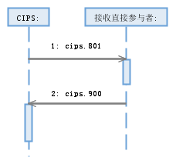
Receiving Direct Participants:

  - Participant Status Management
    - Request/Answer for Login/Logoff
When CIPS finds no error in the RequestForLogin/Logoff message during checking or the message fails to pass CIPS business checks (e.g. no login or no permission, etc.), CIPS will feed an AnswerForLogin/Logoff message back to Initiating Participants.
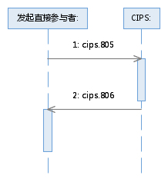
Initiating Direct Participant:

    - Forced Offline Notification
CIPS sends a ForcedOfflineNotice message to Participants.
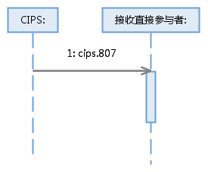
Receiving Direct Participants:
    - Participant Status Change Notification
CIPS sends a ParticipantStatusChangeNotice message to all Participants. Upon receiving this message, the Participants reply to CIPS with a CommonConfirmation message.
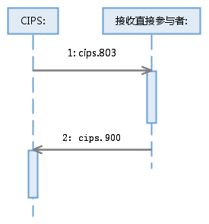
Receiving Direct Participants:

- Example
  - SystemStatusChangeNotice <cips.801.001.01>
Message Instance:
{H:03CIPSCNSHXXX CIPSABOCCNBJXXX CIPS20171211175513XMLcips.801.001.01 2017121100688610 2017121100688610 3U XN}
<? xml version="1.0" encoding="UTF-8"? >
<Document xmlns="urn:cips:std:cips:2014:tech:xsd:cips.801.001.01" xmlns:xsi="http://www.w3.org/2001/XMLSchema-instance">
<AdmstnPrtryMsg>
<MsgId>
<Ref>2017121100000166</Ref>
</MsgId>
<PrtryData>
<Tp>cips.801.001.01</Tp>
<Data>
<OrgnlSysDt>2017-12-11</OrgnlSysDt>
<OrgnlSysSts>ACTV</OrgnlSysSts>
<CurSysDt>2017-12-11</CurSysDt>
<CurSysSts>SUSP</CurSysSts>
<NxtSysDt>2017-12-12</NxtSysDt>
<MmbChngNb>00000025</MmbChngNb>
<ParamChngNb>00000026</ParamChngNb>
<DrctMmbChngNb>00000026</DrctMmbChngNb>
</Data>
</PrtryData>
</AdmstnPrtryMsg>
</Document>

